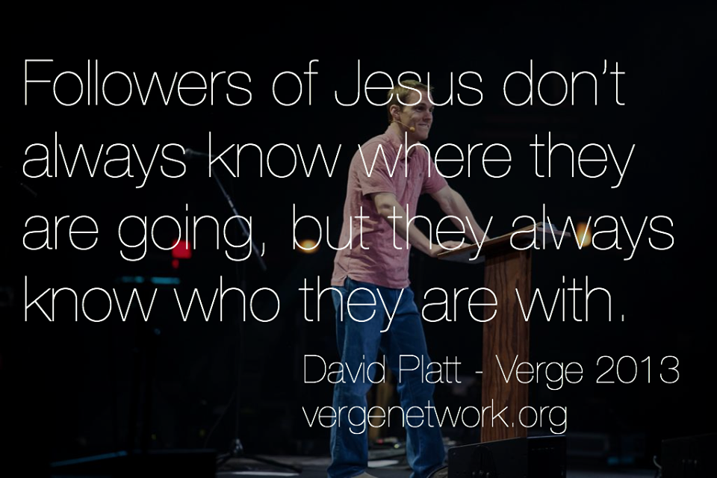

If you are like me, the first question that comes to mind is where do I start when it comes to sharing the Gospel? I love the quote above. Sometimes we don’t know what opportunities Jesus is going to open up in order for us to be obedient to this command. However, you **CAN** do this! He promises in verse 20 of Matthew 28 that ***HE***, is with us. That’s right, the God of the universe is with us, guiding and leading us. We do not have to go about this alone. What an encouragement!

Let’s start by going into "all the world" with the world into which Jesus has placed us. That’s right, we need to start small. Unless God has given you a clear direction to head overseas, then start with where He already has you. First and foremost with your family. So husbands, your role is to lead your family. Better yet, your role is to emulate Christ in your submission and obedience to the role God’s given you in your family through loving, leading and serving them. Make disciples in your own household, so that they may in turn know how to go and make disciples.

Wives, your starting point is to submit to this leading, and thus model what obedience to God’s Word looks like. If being a disciple of Christ means that we mirror Christ and His adherence to the Father’s plan, then it is critical for each of us in the family to be obedient to the roles God has assigned for us. Wives, I’m sure your husbands tell you everyday that you’re a supermodel! Seriously, no one models biblical womanhood better than you when you love, support, and follow your husbands God given responsibility to lead your family.

Children, this applies to you as well. How? Turn to Exodus 20:12.

That’s right, showing honor to your parents is a part of the discipleship process. Don’t think so? Read Ephesians 6:1-2.

Show honor in obedience to your parents in your actions, thoughts and speech.

We will never fully maximize our ability to make disciples in the world until we have done so in our households. Our “world” begins within the home.

Hopefully you had a great night’s sleep last night and your stomach is full from breakfast. A quick re-cap of yesterday’s quiet time-We began the conversation about being commanded to go and make disciples and proclaiming the gospel throughout the whole earth. We also discussed how, if we believe in God, our faith should then have action. That action is obeying and doing what Christ told us to do. So today we are going to dive into how this looks and what that means for us in our daily lives.

**Family**

**Facetime**

**Day Two**

**2 billion! Yep that’s “billion” with a B**. I just recently heard this statistic being quoted from a mission conference. Yes, even if **EVERY CHRISTIAN** where to share the name of Jesus and or the Gospel with everyone in their circle of influence, there would still be over 2 billion people who had not heard!! I can’t even fathom this! It makes me profoundly sad, but it also serves as a clear wake-up call for all of us. This is nothing new, Luke 10:2 addressed this very issue. Take a moment and read what he has to say. What does Jesus say? What is plentiful? What is few?

There is not a lack of people that need to hear the great news of Jesus Christ and know what it means to follow after Him. So the question this morning is this: “ Are you willing to be a laborer?” Are you and I willing to be obedient to the great commission? But do I go local? Regional? Global? **Yes! Yes! And Yes!** We go where he leads and provides. Our obedience is not geographically limited. In fact, I would challenge your family to this over the next year:

What is something **LOCALLY** that we can invest our time into as a family? Maybe it is your kids’ sports team; maybe it’s your neighbors, or a new family to the church. It could be the soup kitchen that you serve at monthly as a family or helping the local crisis pregnancy center. But pick something to invest in.

What is something in the **UNITED STATES** we can be a part of this year? It could be as simple as taking a few hours during a vacation to go and serve a ministry where you are. It could be as simple as finding a nursing home and spending a few hours there. Be creative!

Going or supporting **GLOBALLY.** If you can’t go this year, support a missionary as a family. And then make a plan within the next three years for all or some of the family to go overseas and share. Even if the kids can’t go, parents ,you can model for them by going yourselves.

Prayer Time

God give us a heart for people. Help us to see people the way that you do. God break our hearts for lost people. Help us to always look for opportunities to form relationships and to share the gospel with people. Thank you that you would allow us to be a part of seeing lives changed and your kingdom furthered.