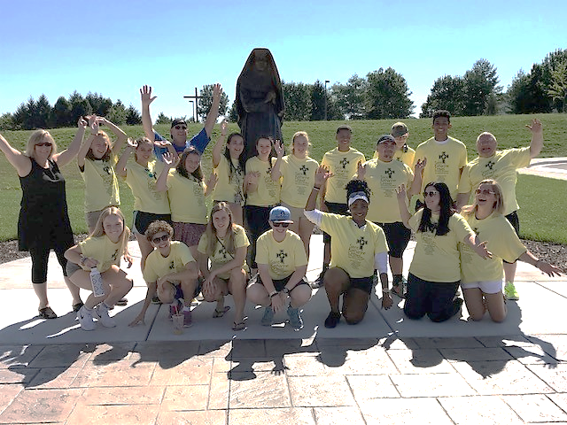  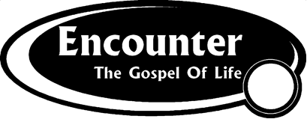  - 8 – 13 July 2018  This is what you have been waiting for…  We are thrilled to again offer a chance for our high school youth to join with over 300 teens in Washington DC for a week long (July 8-13) service retreat that will be filled with awesome speakers, great musicians, and lots of hard (but very cool) work. We will be housed at the University of Maryland, spend our days doing volunteer work in some amazing places (soup kitchens, elder housing, homeless shelters, etc.), and then spend our evenings listening to great musicians & amazing speakers, sharing our experiences, and just having a blast.  This past summer we brought 17 youth from Saint Katharine Drexel and we plan to bring as many or more next summer. Space is limited though, so this is first come, first served. To reserve your spot, you will need to return the SKD permission form (on the back of this flyer) with a non-refundable deposit check for $100 made out to Saint Katharine Drexel. Once you have turned in your permission form you will be emailed more information on how to register.  Your deposit will go towards the total cost of the trip which is $530* for the week. We will be doing lots of fund raising to lower that total and partial scholarships are available.  In order to keep costs down, we try to have parents drive teens to and from the University of Maryland. Please consider helping in this way.  * Cost increases to $580 after 3/25 so register NOW! Final day to register with SKD group is 5/1 | Space is limited and spots will be awarded on a first come first served basis.  ____  To reserve a spot, fill out the permission form on the back of this flyer  ____  Total cost will be $530 but price increases after 3/25 to $580, so sign up quick!  For questions or more information contact:  Ana Maria Alvarado  Ana.alvarado@saintdrexel.org  301-360-9581

ARCHDIOCESE OF BALTIMORE
DIVISION OF YOUTH & YOUNG ADULT MINISTRY
PERMISSION FORM AND RELEASE

Youth Name:____________________________________________ Parent (s) Name: ___________________________________________________

Phone Numbers: Home_______________________ Parent Cell Phone________________________ Youth Cell Phone:________________________

Other number (s) where Parent can be reached: ________________________________________________________________________________

Address _______________________________________________________City/State/Zip_______________________________________________

Email address: Parent - ________________________________________________ Youth - _____________________________________________

Date of Birth _________________ School ______________________________ Grade: _____________ Male Female (please circle)

Emergency Contact Name: ________________________________________Emergency Contact phone # __________________________________

In consideration of the wholesome recreational and learning experience in which my son/daughter will participate, I as parent or guardian of my son/daughter, do hereby agree to allow my son/daughter to accompany the youth ministry/campus ministry group of their parish/school to: Encounter the Gospel of Life, July 8-13, 2018 University of Maryland
$100 non-refundable deposit due at time of registration to secure space

I/we acknowledge receipt of the attached information sheet describing the planned activities.
In consideration of the opportunity for my son/daughter to participate in the Program, I agree to RELEASE AND HOLD HARMLESS AND INDEMNIFY Encounter the Gospel of Life, the University of Maryland, Saint Katharine Drexel Parish, the Division of Youth & Young Adult Ministry, the Roman Catholic Bishop of Baltimore and his successors, a Corporate Sole, and all their agents, servants and employees from any liability, claims, demands and causes of action arising out of or relating to any loss, damage or injury sustained in connection with or arising out of my son/daughter’s participation in the Program.

I hereby grant permission to any staff person to obtain medical care from a licensed physician, hospital, or medical clinic for my son/daughter in the event that I cannot be reached.
(Check one of the following:)

______I am covered by hospitalization and medical insurance under policy
#__________________issued by .____________________________________________

______ I do not have medical coverage and assume responsibility for the cost of hospitalization and
medical care for my son/daughter.

I hereby grant permission to any staff person to provide the following over-the-counter drugs to my
son/daughter if requested by my son/daughter (Circle all that apply:)

Tylenol Benadryl Advil Sudafed Midol Kaopectate Neosporin Pepto Bismol

ADD any other medical information concerning conditions, medication, allergies, illness, etc. ________________________________
___________________________________________________________________________________________________________
ADD any dietary restrictions:___________________________________________________________________________________

Parents/guardians of participants are advised that photographs or videotape of participants may be used in publications, websites or other materials produced from time to time by the Division of Youth and Young Adult Ministry or the Archdiocese of Baltimore. (Participants would not be identified, however, without specific written consent.) Parents/guardians who do not wish their child(ren) to be photographed or filmed should so notify the Division in writing. Please note that the Division has no
control over the use of photographs or film taken by media that may be covering the event in which your child(ren) participate(s).

_________________________ ____________________________
Date Parent/Guardian Signature
Parent/guardians, please circle one: I am / am not interested in driving to this event on Sunday, 7/8 or driving from the event on Friday, 7/13.

