Performing Arts Day Camp 2017
For children who have completed grades K* – 5
*And will be 6 by 8/31/17

Sunday, June 25
5:00 pm - 8:00 pm
Monday, June 26 - Friday, June 30
9:00 am - 12:30 pm

Performances
Friday morning, June 30 at 10:00 am at Croasdaile Retirement Community
Friday night, July 1 at 7:00 pm at Mt. Sylvan UMC

Cost
$45.00 per camper
Please include your payment with your registration form.

Each day of camp your child will participate in singing, learning choreography, practicing lines and solos, recreation, crafts, and dancing. On Sunday night, our supper will be a snack supper in the fellowship hall. Each day of camp we will serve snack and on Friday, after our performance at the retirement home, we will serve lunch. Please plan to bring a snack to share for the Friday night celebration after the concert.
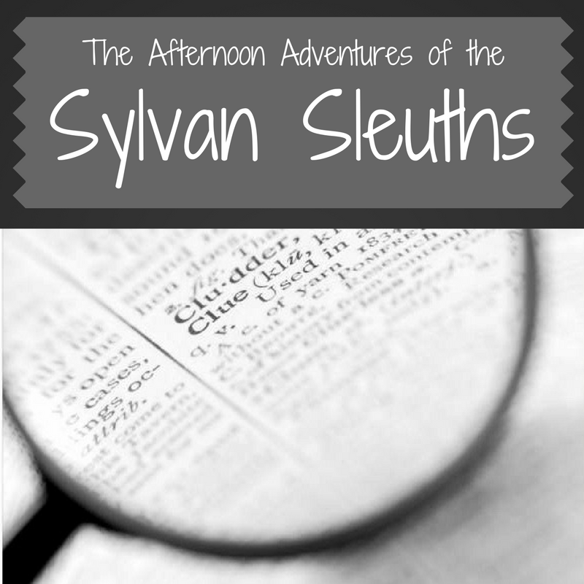

Each afternoon following PADC, from 12:30pm-5:00pm, the Sylvan Sleuths will find clues and discover a new mystery location to explore and enjoy that day! The mystery location will be kept a secret from our “Sleuths” however the adult in their life will have full access to these trips in advance! One day we may venture to the Planetarium and the next we may have to find our way out of a mystery ourselves! Each day is sure to be an adventure that your child will highly enjoy and will make memories that will last a lifetime!
All PADC participants are invited to participate.

*The cost for these trips is additional to the cost of the Day Camp.
Cost per camper/per day- $15 Cost per camper/all trips- $75
*Afternoon trips include lunch and the cost of location.
*Pick-up is at 5pm each day
PADC Registration Form 2017

Child’s Name_______________________________ Birthday_______________ Grade Completed________
Which school does this child attend____________________________________________________
T-Shirt Size (circle) Child 6/8 Child 10/12 Child 14/16 Adult Small Adult Medium
Does your child have any dietary restrictions? __________________________________________________
Will your child need to take any medications while at camp? ______________________________________
My child would like: a solo A speaking part
**Children must attend both performances to be considered for a solo or speaking parts**
My child will attend performances on: Friday morning Friday evening

Child’s Name_______________________________ Birthday_______________ Grade Completed________
Which school does this child attend___________________________________________________
T-Shirt Size (circle) Child 6/8 Child 10/12 Child 14/16 Adult Small Adult Medium
Does your child have any dietary restrictions? __________________________________________________
Will your child need to take any medications while at camp? ______________________________________
My child would like: a solo A speaking part
**Children must attend both performances to be considered for a solo or speaking parts**
My child will attend performances on: Friday morning Friday evening

Family Information
Mailing Address _____________________________________________City ____________ Zip code __________ Home phone ____________________Where does your family attend church, if any? ______________________
Mother’s Name ____________________________________________________
Work number__________________ Cell number _____________________
Preferred email for PADC Communication ________________________________
Father’s name _____________________________________________________
Work number__________________ Cell number _____________________
Preferred email for PADC Communication ________________________________

Who has permission to pick up your child after PADC?
List all names and their relationship to your child.

NAME CONTACT NUMBER RELATIONSHIP

In case of an emergency where neither parent can be reached, who should we call?
List all names and their relationship to your child.

NAME CONTACT NUMBER RELATIONSHIP

Can we use your child’s picture on church promotional materials or on the church website?
(Please initial your response.)
Printed church promotional materials Church website
_____ yes _____ no _____ yes _____ no
Parent signature to authorize use of child’s picture ____________________________________________________
How are you willing to help with PADC this week?

Serve as a daily chaperone | Serve as a chaperone/driver Friday morning
Provide snack | Help clean up Fellowship Hall Friday night
Help set up Fellowship Hall Sunday afternoon | Help clean up Sanctuary Friday night
PADC Payment Information
Total number of Children _______ x $45.00 per child = Total cost for PADC $ _______
Payment enclosed- Total $ _______ Check #- ____________

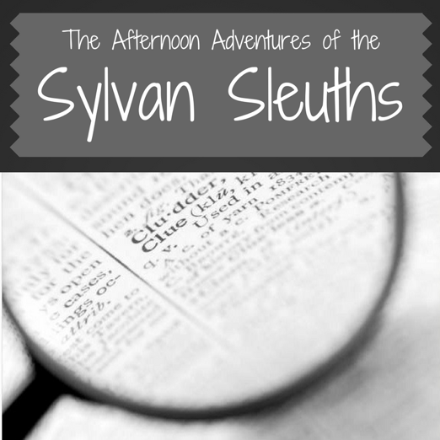

Sylvan Sleuths Registration

Child’s Name______________________________________ Age:____________ Grade:__________

Child’s Name______________________________________ Age:____________ Grade:__________

Please indicate which days your child(ren) will be participating in our Afternoon Activities
Monday –June 26th _______
Tuesday – June 27th _______
Wednesday- June 28th _______
Thursday- June 29th _______
Friday- June 30th _______

Payment Information
The cost for each day is $15 or $75 for the whole week per child.
Using this information please indicate the total payment due.
Payment enclosed: Total payment: ________________ Check #:_______________

For more information or for questions
contact Ms. Elizabeth at Elizabeth@mtsylvan.org
or contact Ms. Kathie at Kathie@mtsylvan.org

