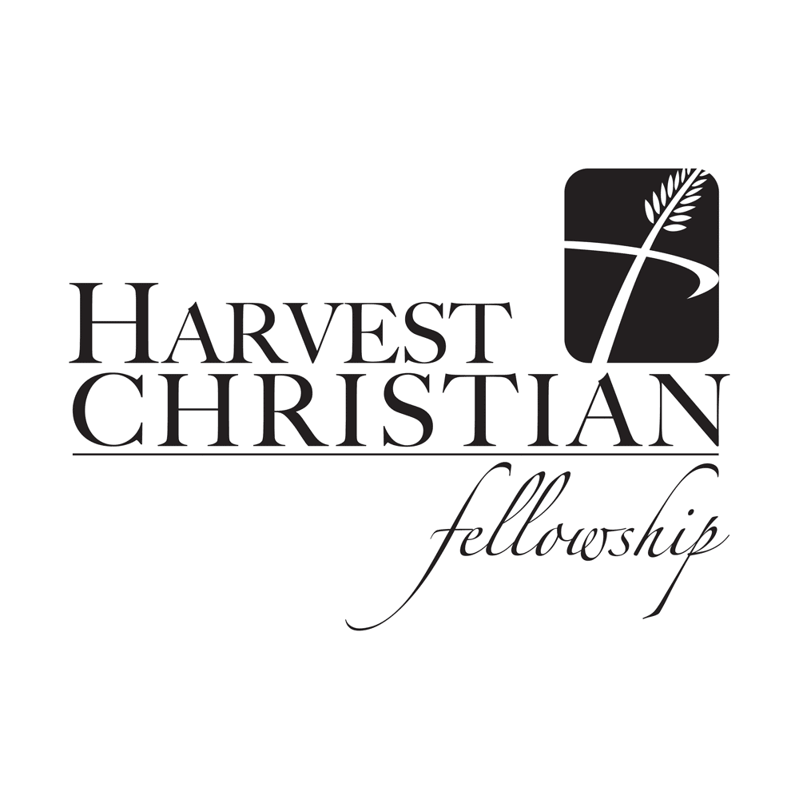
September 20, 2015
Congregational Singing Harvest Praise Team
Give Us Clean Hands
Welcome and Announcements Chad Seay
Quiet and Worshipful Reflection Alex Crain
As the Deer
Invocation/Prayer of Confession David Walker
Congregational Singing Harvest Praise Team
How Great Thou Art
Glorious and Mighty

Children’s Catechism – All children K-5 are invited to come forward.
Prayer & Worship through Giving Jim Largen
Offertory/Congregational Singing Harvest Praise Team Sovereign Over Us
If you are visiting with us today please do not feel compelled to give. If you filled out a visitor card feel free to put it in the offering basket.
Worship in the Word "Chasing the Wind" Joel Bradberry
Ecclesiastes 1:1-11
The Lord’s Supper Elders
Church Covenant Alex Crain
Closing Song Harvest Praise Team
Jesus Thank You
Benediction Alex Crain
Numbers 6:24-26
Please pray for Pastor Joel and our congregation as he preaches a sermon series on Ecclesiastes.

Question/answer for this week’s Children’s Catechism – What is the Lord’s Prayer? …your kingdom come ……
New Member’s Classes are in progress. They are at 4:00pm at the church office in the Seay Realty Building. You are free to join in and please know that commitment to the new members’ class does not obligate you to join HCF.
Our next Members’ Meeting will be Sunday, September 27th at 7:00pm at Fairmount Christian Church. It will be a very important meeting as we will introduce proposed changes to our by-laws regarding the definition of marriage among other things.
Vision Virginia Week of Prayer & Offering for State Missions is Sept. 20-27th. The SBCV goal for this year is $250,000 – 100% of which will go directly to support missions in Virginia and beyond. Our state Missions offering will be September 27th. Please be in prayer about how God would have you respond to this mission offering.
Community Groups Return! Grow closer to God and your church family by getting involved in a Community Group this fall! Harvest Community Groups meet in homes usually twice a month. We focus on prayer and fellowship together as well as discussion of the Sunday morning sermons. We will begin meeting the week of Oct. 11th and will continue through May 22nd. Let us know of your interest and availability by completing the form in today's bulletin. (Forms to be collected during the offering.)
New Theology@9 Classes beginning Oct. 4th:
Biblical Theology - understand not only what the Bible teaches, but to do so in the context of the Bible’s own progressively revealed and progressively developing story-line. 13 week course. Teacher – Wes Loveday
How to Study the Bible - Over the next 13 weeks we will consider: the most important methods of interpreting the Bible, the Bible’s structure, and some specific study tools and methods to allow us to better understand the bible. The goal of this class is to give you a greater love for God and his Son by assisting you in learning how to fruitfully read and understand the Bible. 13 week course. Teacher – Joel Bradberry
Money - The purpose of our time together will be to help us better understand God's intention for how we use our money and possessions. Our focus will be centered upon what the Bible teaches about God's purpose for wealth, gracious giving, spending, budgeting, debt, saving and how to develop a heart which values money rightly. 6-week course beginning October 4th. Teacher – David Walker
Guidance - The world and even Christians have developed some unbiblical ideas about how God guides our decisions - and yet the Scriptures give us some amazing truths about how God does guide us. We'll be looking at Anxious or Restful decisions, God's Sovereignty, God's Will and how we can apply these truths to our decision making process. 7-week course beginning Nov. 15. Teacher – David Walker
Men’s Bible Study - Men’s 24/27 Bible Study meets on Friday mornings at 6:00am at the HCF Office (Seay Realty).
Women’s Bible Study – Wednesdays at 10:30am to 12:00 noon at the home of Priscilla Riley, 3731 Horseshoe Drive, Quinton, VA. The ladies are currently studying the book of Romans.
Youth Worship Service – Wednesdays at Old Church Community Center, 2080 Old Church Road, Mechanicsville - 6:45 to 8:00pm.
There will be an elder (Joel Bradberry) available in the front office at the conclusion of worship to pray with you or attempt to answer any questions you have about HCF or the Christian faith.

HCF Elders
Buddy Pritchard, Buck Wicker, John Riley, Wesley Loveday, Joel Bradberry, and David Walker.

HCF Staff

Joel Bradberry - joel.bradberry@hcfellowship.com - (212-4087) Pastor
Wesley Loveday - wesley.loveday@hcfellowship.com - (335-8874) Associate Pastor (Youth)
Pastor Alex Crain - alex.w.crain@gmail.com - (441-1003) Worship Leader
Nancy Wicker - nancy.wicker@hcfellowship.com Administrative Assistant
Church Offices at 7031 Creighton Road (Seay Real Estate Bldg.)
Church Telephone - 559-4232
Website – www.hcfellowship.com
Worshiping at Cold Harbor Elementary School
6740 Cold Harbor Road
Mechanicsville, Virginia

Sunday School & Theology @ 9 – 9:00A.M.
Worship Service - 10:15 A.M.

“Vanity of vanities, says the Preacher, vanity of vanities! All is vanity.”
Ecclesiastes 1:2

