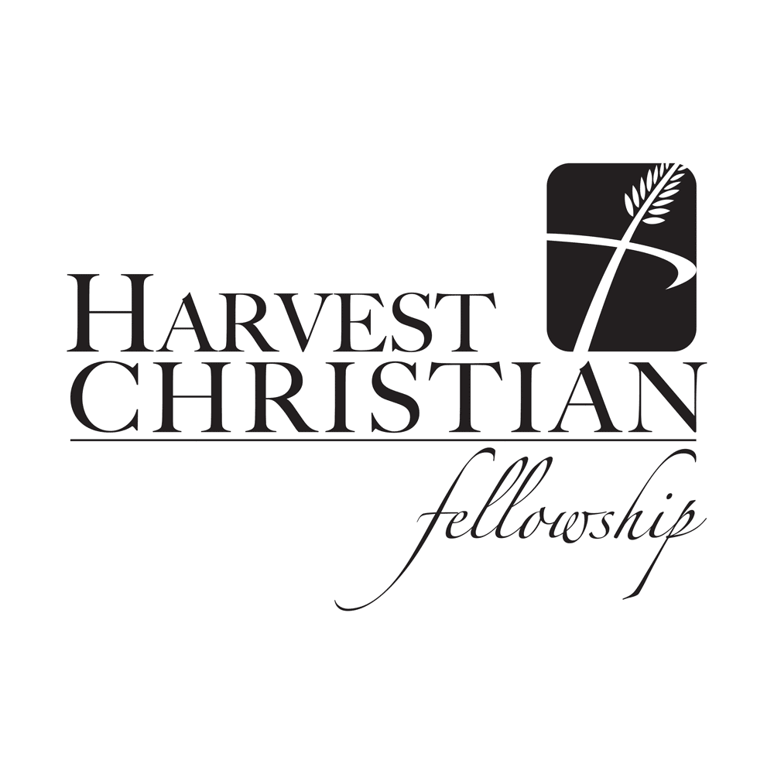
July 19, 2015
Welcome and Announcements Joel Bradberry
Quiet and Worshipful Reflection Ariel Gilley
Invocation/Prayer of Confession Buck Wicker
Congregational Singing Harvest Praise Team
God Moves
Blessed Be Your Name
We Believe

Children’s Catechism – All children K-5 are invited to come forward.
Pastoral/Offertory Prayer Joel Bradberry
Offertory/Congregational Singing Harvest Praise Team
Mercy
If you are visiting with us today please do not feel compelled to give. If you filled out a visitor card feel free to put it in the offering basket.
Message “A Love That Won’t Let Go” Joel Bradberry
Hosea 3:1-5
Closing Song Harvest Praise Team
God Moves (reprise)
Benediction Alex Crain
II Peter 1:2
Preaching schedule: Please begin praying and studying now for the following sermon series:
Beginning August 2nd: “More Than Musings of an Old Preacher.” We will work our way through all 12 chapters of the Book of Ecclesiastes. This promises to be a challenging series for us all.
Question/answer for this week’s Children’s Catechism – Since we are redeemed by grace alone, through Christ alone, must we still do good works and obey God’s Word? Yes, so that our lives may show love and gratitude to God; and so that by our godly behavior others may be won to Christ.
Attention HCF Youth! The sign-up sheet for this year’s Back-to-School retreat is available on the back table.
Everyone can help! Our church family is asked to pray for our VBS workers and pray that the children in each community will take part and be reached for Christ.
Join us for Harvest Christian Fellowship’s VBS Family Fun Day this coming Saturday, July 25th from 3:00 to 7:00pm at the home of Todd & Amy Martin, 3341 Legacy Lane. The VBS Program will be at 4:30 and supper will be served at 5:00pm. HCF will provide hot dogs/hamburgers and drinks. Each family is asked to bring a side dish (initials N-Z) or a dessert (initials A-M).
Member and visitor nametags. If you need a nametag, please see Scott Croxton, Matt Sluder or Rob Roberts. Please remember that our desire is that everyone possess and wear a nametag.
HCF is looking forward to continuing our partnership with the Church of Druisk in Belarus. We’ll be headed to Belarus July 28th – Aug 4th to participate in the family camp ministry. And then again Nov 2nd – 10th for home evangelism, teaching and work projects. If you have any questions or sense the Lord leading you to participate, please see David Walker (phone: 804-387-4837 or dwalker@zip-corvette.com)
The following New Theology@9 Classes have begun:
New Testament- Part 2 - A 26 week course (2 semesters) to understand the big picture of each book of the New Testament, the continuity between the books in the NT, to realize the Promises God has kept to His People from the OT and to hear God speak to us today through His Word and so to be challenged in our lives. This class will be in a class down the hall from the library and taught by Buddy Pritchard.
Parenthood – Scripture teaches that a primary purpose of the family is nothing less than presenting the whole world with a series of three images, God’s triune nature, the gospel, and the church. This class will be in the library and will be taught by David Walker.
Evangelism –This is a 13 week study about one of the main purposes of our life – to proclaim the Gospel of Jesus Christ. In Matthew 28:18-20 Jesus said “All authority in heaven and on earth has been given to me. Go therefore and make disciples of all nations, baptizing them in the name of the Father and of the Son and of the Holy Spirit, teaching them to observe all that I have commanded you. And behold I am with you always, to the end of the age”. That’s what this class is all about. We want to equip you, encourage you and exhort you to be disciple-makers. This class will be in the auditorium and will be taught by Joel Bradberry.
Attention High Schoolers! - The Richmond Center for Christian Study will offer a one-week course (July 27-31, 9:30am-11am) entitled "Exploring the Truthfulness of a Biblical Worldview." We will look at questions such as how to evaluate competing worldviews, what science says about the origin of life, what history says about the resurrection of Jesus, the reliability of the Bible, and homosexuality as an ethical test case. Each session is 45 minutes long, followed by 45 minutes of Q&A discussion. Registration is $75. Register by July 23 by calling 804-852-5151. More info at richmondstudycenter.org
Men’s Bible Study - Men’s 24/27 Bible Study meets on Friday mornings at 6:00am at the HCF Office (Seay Realty).
Women’s Bible Study – Wednesdays at 10:30am to 12:00 noon at the home of Priscilla Riley, 3731 Horseshoe Drive, Quinton, VA. The ladies are currently studying the book of Romans.
Youth Worship Service – Wednesdays at Old Church Community Center, 2080 Old Church Road, Mechanicsville - 6:45 to 8:00pm.
There will be an elder (David Walker) available in the front office at the conclusion of worship to pray with you or attempt to answer any questions you have about HCF or the Christian faith.
HCF Elders
Buddy Pritchard, Buck Wicker, John Riley, Wesley Loveday, Joel Bradberry, and David Walker.

HCF Staff

Joel Bradberry - joel.bradberry@hcfellowship.com - (212-4087) Pastor
Wesley Loveday - wesley.loveday@hcfellowship.com - (335-8874) Associate Pastor (Youth)
Pastor Alex Crain - alex.w.crain@gmail.com - (441-1003) Worship Leader
Nancy Wicker - nancy.wicker@hcfellowship.com Administrative Assistant
Church Offices at 7031 Creighton Road (Seay Real Estate Bldg.)
Church Telephone - 559-4232
Website – www.hcfellowship.com
Worshiping at Cold Harbor Elementary School
6740 Cold Harbor Road
Mechanicsville, Virginia

Sunday School & Theology @ 9 – 9:00A.M.
Worship Service - 10:15 A.M.
“And the Lord said to me, ‘Go again, love a woman who is loved by another man and is an adulteress, even as the Lord loves the children of Israel, though they turn to other gods and love cakes of raisins.’ So I bought her for fifteen shekels of silver and a homer and a lethech of barley. And I said to her, ‘You must dwell as mine for many days. You shall not play the whore, or belong to another man; so will I also be to you.’ For the children of Israel shall dwell many days without king or prince, without sacrifice or pillar, without ephod or household gods. Afterward the children of Israel shall return and seek the Lord their God, and David their king, and they shall come in fear to the Lord and to his goodness in the latter days.’”
Hosea 3:1-5

