Welcome to
Sonshine Christian Preschool

At the
First Baptist Church of Westerlo
618 SR 143
P.O. Box 130
Westerlo, NY 12193
(518) 797 3927
Welcome
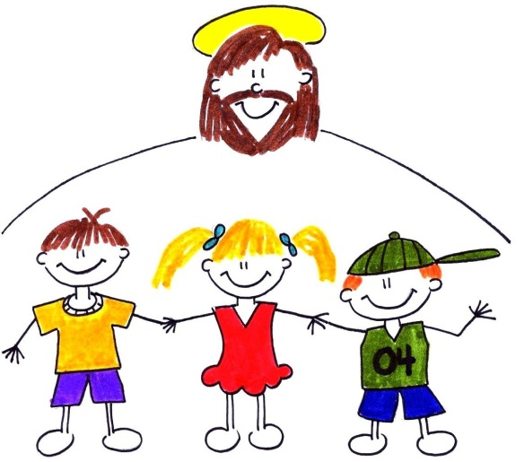

Thank you for inquiring about the Sonshine Christian Preschool of the First Baptist Church of Westerlo. We are a preschool where the Son shines into our teaching! It is our commitment to provide a quality Christian education to students four years of age by December 1st of the applying school year. We believe that learning should be fun and look forward to having the opportunity to teach your child our Biblically based academics in a hands-on, loving environment.

This handbook has been prepared to provide you with general information about our preschool program. Also enclosed are an application, permission slip, and Physician’s report to be completed and returned with your registration fee should you decide to apply. Please feel free to phone the church office with any additional questions you may have. We would love to talk to you.

Table of Contents
General Information
Statement of Philosophy………………………………………………………… 4
Administration………………………………………………………………………….. 5
Doctrinal Statement……………………………………………………………….. 6
Financial Information………………………………………………………………. 7
Educational Goals…………………………………………………………………….. 8
Curriculum…………………………………………………………………………………… 9
Daily Schedule………………………………………………………………………….. 10
School Closings………………………………………………………………………... 10
General Policies
Classroom Standards…………………………………………………………….… 11
Discipline…………………………………………………………………………………….. 12
Holidays……………………………………………………………………………………... 12
Birthdays……………………………………………………………………………………. 13
Field Trips………………………………………………………………………………... 13
Communication………………………………………………………………………….. 14
Visitors……………………………………………………………………………………….. 14
Emergency Plan……………………………………………………………………….… 15
Guidelines for Sickness………………………………………………………….. 15

Statement of Philosophy
As a Christian preschool, we recognize our task as being one of teaching that in life, man is incomplete and inadequate without a proper relationship to God. This involves teaching both the Truth of God as found in His Word, the Bible, and also truth as it exists in God’s Creation. We recognize that God is the author and source of all Truth, and that true education is gaining the perspective and integrating it into all teaching.
We recognize that man and all of creation were brought into being to bring glory to God. Because of man’s sin, the result is a separation from God. Jesus Christ, God revealed in human form, came to earth and paid the penalty for man’s sin. Jesus Christ is the only mediator between God and man and is the source of all wisdom and knowledge. This wisdom and knowledge is taught and applied to life by the Holy Spirit. It is this application of Truth that constitutes Christian education.
Man has a value and worth because he was created by God and in the image of God. Man also has a sin nature which has separated him from God, therefore the only way back to God is forgiveness through accepting Jesus Christ as Lord and Savior. As a Christian preschool, our commitment is to teach Truth, not about truth; to teach Jesus Christ, not about Jesus Christ. This commitment is based on the study and integration of God’s Word and the fear of the Lord.
Administration
The administrative policies of Sonshine Christian Preschool are made by the Christian Board of Education of the First Baptist Church of Westerlo. This board consists of the Senior Pastor, two Deacons, the Sunday School Superintendent and two elected members of the church.

Parents are encouraged to bring any concerns they may have to the attention of the Sonshine Christian Preschool Director and she can take them to the Christian Board of Education if necessary. You may also contact the First Baptist Church of Westerlo office if you have an item you would like placed on the board’s agenda.

All teacher applications are reviewed by the Christian Board of Education as well as the Deacon and Trustee Boards of the First Baptist Church of Westerlo.

Doctrinal Statement
- We believe that the Bible is the complete and infallible Word of God, verbally inspired, and is of supreme and final authority in all matters pertaining to faith and practice. II Timothy 3:16
- We believe in one God eternally existing in three persons: Father, Son, and Holy Spirit. John 14:16 Matthew 3:16-17 Matthew 28:19-20
- We believe that Jesus Christ was begotten of the Holy Spirit and born of the Virgin Mary, and that He is true God and true man. Matthew 1:20 Luke 1:35 John 1:1-2 John 12:45 John 14:9
- We believe that Jesus Christ is the one all-sufficient mediator between God and man. I Timothy 2:5
- We believe in the personality of the Holy Spirit and that His ministry is to reveal Christ to men in the regeneration and sanctification of their souls. John 16:7-11 John 14:17
- We believe that man was created in the image of God, and that he sinned and thereby incurred spiritual death which is everlasting punishment.
Genesis 1:26 Genesis 3:3
- We believe in the vicarious death of the Lord Jesus Christ for our sins, and that all who believe in Him are justified on the grounds of His shed blood, in the resurrection of His body, His ascension into Heaven and His personal and visible return to the earth. I Peter 1:19 I Corinthians 15:3 Acts 1:10-11 I Peter 3:18 I Thessalonians 4:14-18 II Timothy 2:8
- We believe in the resurrection of the dead, both the just and the unjust, the righteous going to everlasting life and the wicked to everlasting punishment.
Acts 24:15 John 5:28-29
- We believe that salvation is the gift of God and is received and experienced only through personal faith in Him. Ephesians 2:8-9 Acts 16:31 John 3:16, 36 John 10:28-29 I John 5: 11-12
- We believe that the immersion of the Believer in water, in the name of the Father, and of the Son, and of the Holy Spirit is Baptism as set forth in the New Testament. Romans 6:1-11 Matthew 3:13-17 Acts 2:38 Acts 8:36-39
- We believe that the ordinance of the Lord’s Supper commemorates His death until He comes.
Matthew 26:26-30 I Corinthians 11:23-30
- We believe that each local church has the right to be independent and autonomous and must be free from interference by any ecclesiastical or political authority. Acts 6:2-3 Acts 4:18-20 II Corinthians 8:19

This doctrinal statement is taken from the Constitution of the First Baptist Church of Westerlo
Financial Information

Annual Student Tuition……….………………………….$900.00
Non-refundable registration fee
(to be submitted with application)……………… $100.00
Balance Due………………………………………………….... $800.00

Payment Options
- Receive a $50 discount for paying your tuition in full for the year by the first day of preschool. Your balance due after registration would be $750.
OR
- Make 10 monthly payments of $80.00 each beginning in September and ending in June. Payments are due on the first of the month and can be hand delivered to the Director at preschool or mailed with envelopes provided for your convenience. A late fee of $10 will incur after the 10th of the month.
Educational Goals
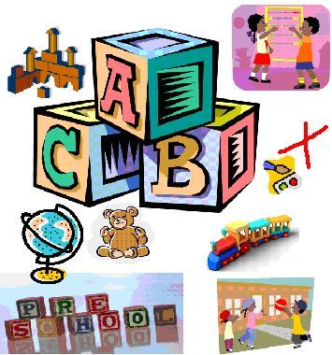
Based on our philosophy of education, each individual child will be encouraged to learn and grow….
Spiritually
with Jesus Christ
Cognitively
by gaining greater knowledge and understanding
Socially
through positive interaction with teachers and peers
Emotionally
by creating positive self-worth
Physically
by developing strong, healthy bodies
Creatively
through art, music and movement
Curriculum
It is our goal to prepare your child for successful Kindergarten entry. Each student is treated as an individual and encouraged to grow at his/her own rate. Our themed curriculum is based on our educational goals and includes:
Activity Centers:
- Dramatic play area for role playing
- Block center for dexterity and pre-math concepts
- Manipulative games and puzzles for dexterity, cognitive growth, and developing fine motor skills
- Library for early literacy and language skills
- Science for discovering God’s World
- Writing upper and lower case letters, numbers and names
- Creative arts and crafts, sensory stimulation
Circle Time:
- Relational skills are developed
- Calendar and weather
- Letters, numbers, shapes, and color reinforcement
- Music, movement, singing, and instruments
Bible Time:
- Worship
- Bible stories from the Old and New Testaments emphasizing Christian life application
- Bible verses
- Sharing and prayer time
Recess:
- Large, multi-purpose ARK facility for physical activity, large motor skill and social development
- Outdoor playground
Daily Schedule 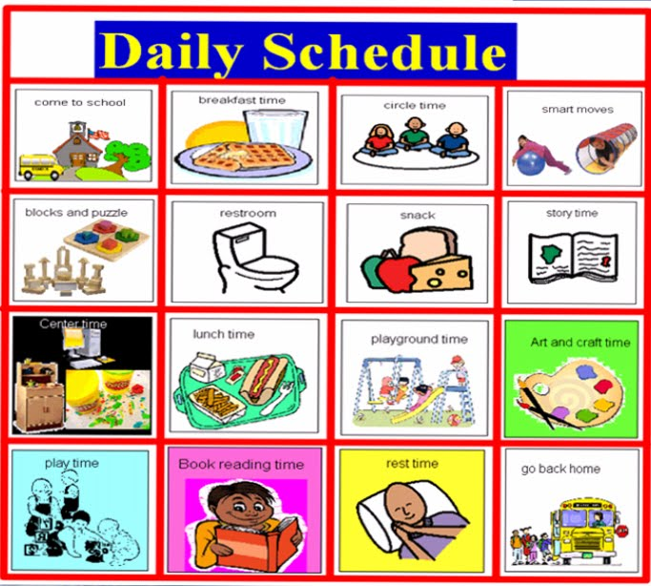
Sonshine Christian Preschool operates on Tuesday, Wednesday and Thursday mornings from 9:00am to 12 noon. Our classes begin in September and end in June. Students who will be 4 years of age by December 1st of the applying school year are eligible to apply and will be enrolled on a first come, first served basis.
It is requested that students arrive no sooner than 10 minutes before school begins to allow teachers prayer and preparation time. Please pick up children promptly at the close of school. It is important that you inform the teacher (in writing whenever possible) of any arrangements you have made for your child to be picked up by someone other than their parent. A class list will be made available if you would like to talk to other parents about carpooling.
School Closings for Inclement Weather
Sonshine Christian Preschool will follow the Berne-Knox-Westerlo school district (BKW) for closings due to inclement weather. If BKW is 1 hour delayed, we will start on time at 9:00am. If BKW is 2 hours delayed, we will start at 10:00am. Dismissal time will still be at 12 noon. If BKW is closed, Sonshine Christian Preschool will be closed.

Classroom Standards
We want your child to feel as comfortable as possible on their first day of preschool. We suggest you introduce your child gradually by attending student orientation day. This is an opportunity for the students to attend preschool with their parents, meet the staff and fellow students, and see the classroom and things they will be doing.
All children should wear comfortable clothes and shoes so they will be free to enter into play. Long dresses and smooth soled shoes and some sandals can be difficult to play in and may cause a fall. Girls wearing dresses are required to wear shorts underneath as to remain modest when on the playground or during circle time.
Students are required to bring a backpack/tote bag and folder to preschool daily for transporting their papers, art, snacks and any other miscellaneous items. Please also include a change of clothes in a Ziploc bag with their name on it in case of an unexpected accident.
We are prepared to serve only healthy children. We ask that you send your child to school only if he/she is not ill. (Please take a look at the guidelines for sickness on page 15)
All children should come to school with a nutritional snack and drink for our snack time. Please make sure to bring to the teacher’s attention any allergies your child may have as special treats are served for birthdays and holidays.
All children must be toilet trained before entering preschool. Please bring your child to the bathroom before entering class.
Discipline
We make every effort to have a discipline policy that practices positive reinforcement by praising good behavior and teaching self-control. If a child’s behavior indicates he may harm themselves or others or seems to be taking away from the educational opportunity of others, he/she will be temporarily removed from the immediate group. This will only be for a short time to help the child settle down and reflect on his/her behavior with the teacher’s guidance so they can rejoin the group. We believe discipline should be an opportunity to train the child in love. If a child has a continuing problem, the parent will be contacted for a conference so we can work on the problem together and maintain consistency.

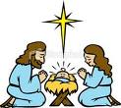 Holidays 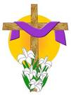

Holidays are fun and exciting for the children to celebrate together. We may hold a special program or enjoy festive treats. The teacher will communicate with parents to let them know how they can participate.

Birthdays
Your child’s birthday may be celebrated at preschool by scheduling a date with the teacher. Parents may provide a special treat to share during our snack time. Special paper products or favors for the class may be sent in but are not necessary. If you are having a birthday party for your child and wish to send invitations to preschool, you may do so if the whole class or all boys/girls are invited. Otherwise, we would prefer you send them by mail to avoid hurt feelings.

Field Trips

Sonshine Christian Preschool will provide field trip opportunities at different times throughout the year. They will be communicated to the parents through our monthly calendars and newsletters. Parents are welcome and encouraged to attend with the students. We will carpool and/or use the FBCW church vans for transportation. Booster seats must be provided.

Communication
While we don’t schedule Parent/Teacher conferences throughout the year, open communication is incredibly important. I will contact you as the parent or guardian if I feel there are any concerns that need to be addressed with your child. I encourage you to contact me at anytime if you would like to discuss your child.

Visitors
Parent visits are welcome anytime. However, please schedule them whenever possible to avoid too many changes to our daily schedule. If you have any outside observers (i.e. speech therapist) that need to come, please have those visits scheduled through the director. You may also speak to the director if you are interested in helping in the classroom on a regular basis.

Emergency Plan
Our emergency plan is as follows:
- Isolate ill or injured child with a teacher.
- Facilitate First Aid if necessary.
- Contact parent or guardian immediately if serious.
- Call for Westerlo Ambulance if necessary.
- Record all illness and injuries immediately.
We do not have a nurse on staff at Sonshine Christian Preschool. However, all teachers and teacher assistants are CPR and First Aid certified. We also practice with the students our emergency exits during fire drills.

Guidelines for Sickness
It is in everyone’s best interest if children stay home if they are not feeling well and would have trouble keeping up with the group. We rely on parent’s judgment on whether or not to send their child to preschool. Most infections are spread before a child appears sick or begins exhibiting symptoms; however, please do not send your child to preschool if they exhibit the following symptoms: a fever or having had one in the last 24 hrs.; thick, colored nasal secretions; vomiting or acute diarrhea; a red, sore throat; an eye infection that hasn’t been treated; infected, untreated skin rashes or lesions; rapid or labored breathing; severe pain or discomfort; or a communicable disease (such as pertussis) that is still in the contagious stage.

