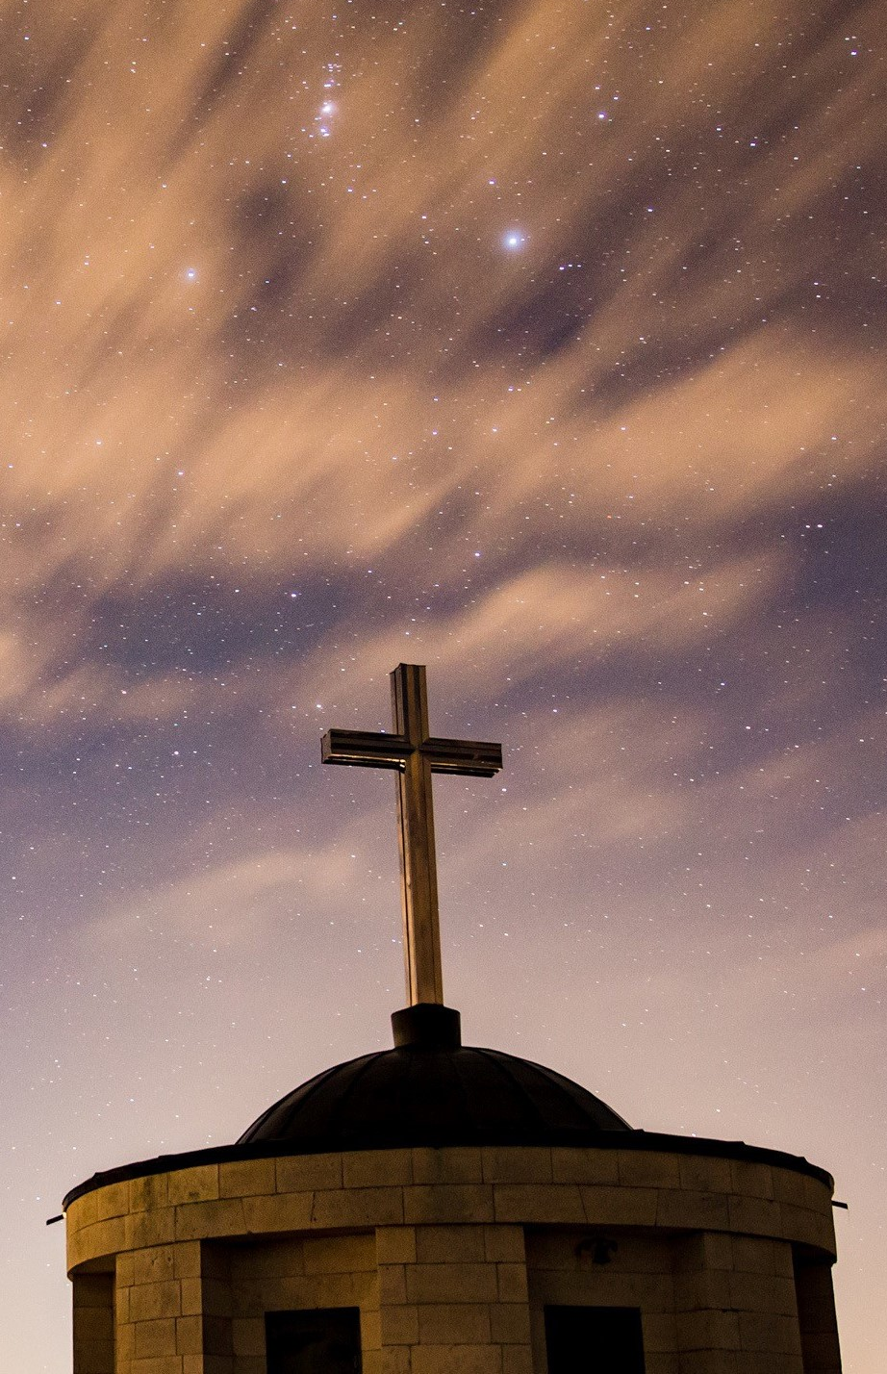
FIRST BAPTIST CHURCH
Of Coronado

445 C Ave
Coronado, CA 92118
(619) 435-6588
fbcoronado.com
Jim W. Baize, Pastor
Julie Burkhart, Secretary, Nursery Coordinator
Fitz Lee, Treasurer
Cathy Joy, Children’s Ministry
Rachel Gorken, Ladies’ Ministry
Jamey Johnston, Men’s Ministry
Bobby Greer, Maintenance
Our mission is to produce fully devoted followers of Jesus Christ. If we can be of any help to you, feel free to give us a call.

If you wish to serve in a ministry, we are looking for YOU!

Matthew 28:6
He is not here; He has risen, just as he said. Come and see the place where he lay!

“HE IS RISEN!!!”

We do not worship a dead Savior. He is not still in a tomb, decomposed, somewhere outside the walls of Jerusalem. He is alive! And He is seated at the right hand of God, His Father, ever making intercession for us! Easter is a holy day unlike any other of any religious denomination or sect.

No one else worships a Risen Savior – not Buddhists, not Jews, and not Islam. Only Jesus Christ has come to this world, lived a perfect life, died a literal death, been buried in a borrowed tomb, and risen again on the third (or any other) day!

The world, the flesh, and the devil all conspired together against Him. Why? Just because He loved us so much! They tried to do Him in for good, but…

The crowds could not silence Him.
The Jews could not marginalize Him.
The Devil could not kill Him.
Rome could not defeat Him.
The shroud could not contain Him.
The grave could not hold Him.
And death could not claim Him,
for He, alone, has the keys
to death, hell, and the grave!

Is He YOUR Savior today? He wants to be. Why not invite Him into your life and trust Him to forgive your sins and to take you home to heaven forever?!

Have a Blessed Easter!

Pastor Jim W. Baize

This Week:

Monday, April 17th – Ronald McDonald House Event 4-8PM with childcare available.

Friday, April 21st – NO LADIES’ BIBLE STUDY

Saturday, April 22nd – Grace Yoga 8:30AM at FBC Coronado.

Upcoming Events!

Sunday, April 23rd Pastor Baize continue his Apologetics Series with “Why Do I Believe In the Rapture?”.

No ladies’ Bible Study Friday, April 28th.

We are planning a new member ship class to take place soon. If you are interested in becoming a member of FBC Coronado please sign up for this informative class with Julie at secretary@fbcoronado.com. Lunch will be served and child care will be provided.

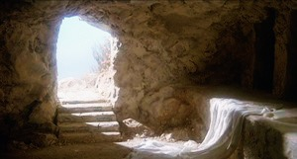
Men’s Discipleship Class Saturday, May 5th at 8:00AM at FBC Coronado.

HE IS RISEN!!!

