Bull
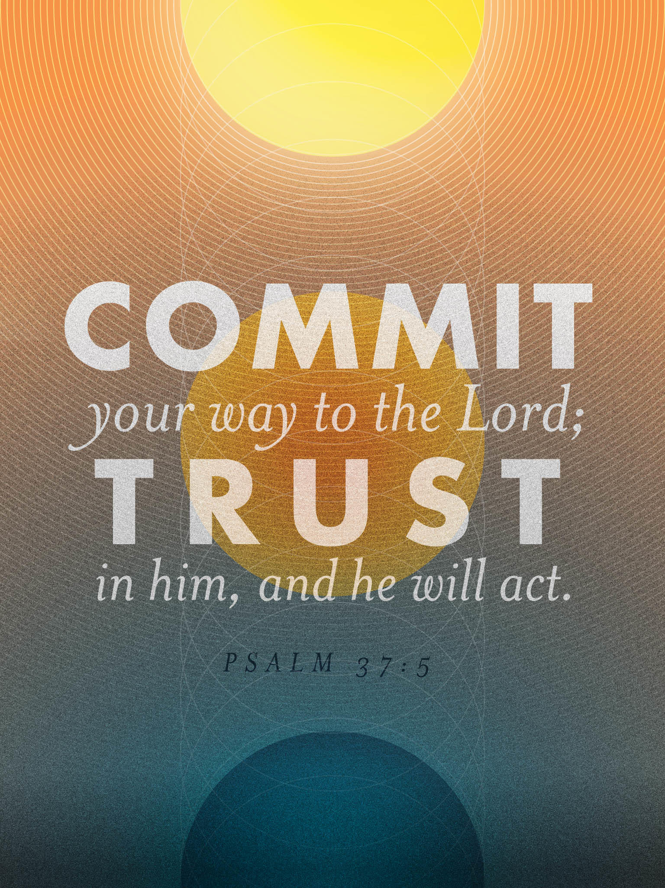
Psalm 37:5
First Baptist Church

445 C Ave
Coronado, CA 92118
(619) 435-6588
fbcoronado.com

Jim W. Baize, Pastor
Julie Burkhart, Secretary,
Nursery Coordinator
Agathe Lee, Children’s Ministry
Rachel Gorken, Ladies’ Ministry
Jamey Johnson, Men’s Ministry
Bobby Greer, Maintenance
Fitz Lee, Adult Class Teacher
Jessi Irwin, Sheerah Haywood
Music Ministry

Our mission is to produce fully devoted followers of Jesus Christ. If we can be of any help to you, feel free to give us a call.

If you wish to serve in a ministry, we are looking for YOU!
Questions: secretary@fbcoronado.com

Upcoming Events

THIS IS A BUSY DAY AT FBC!

This is, indeed, a busy day at First Baptist Coronado! First of all, I want to say “Welcome” to our guests today. You could have chosen to be at a hundred different places right now, but you are HERE and we are blessed! We hope to see you again soon.

Next, we have with us a missionary family, the Mowads, going to the field of Thailand. Welcome them and be sure to pray for them. In addition, we will be doing two things at the end of our preaching service: 1) we will ask you to consider what your “next step” is, and we will encourage you to commit to that step. Are you saved? You need to be. Are you baptized? We can take care of that. Have you joined? Is this where God would have you be? Do you have a ministry? You can sign up today! 2) We will be dedicating babies and children to the Lord at the end of today’s service. If you would like to participate, feel free to come to the front with your children when prompted to do so.

The last two things for today: 1) we will have a New Member’s Class right after church. Lunch will be provided for you and your children. 2) Nominations for potential Leadership Team members must be submitted by today. Make sure any names you submit meet our qualifications and are willing to serve.

Next Sunday we will have communion. It is also our “All Tithe” Sunday. What if every one of us was obedient in giving the first 10% of our income to the Lord?! I hope you will consider tithing for our “90 Day Challenge” if you have not tithed before. Let’s give and serve in 2017. Remember our slogan, “Every member a minister!” May God bless you and our church!

Pastor Jim W. Baize

This Week

Wednesday Feb. 1st Couples’ Bible Study 6:30-8PM Thursday 2nd Lassiter’s Bible Study 6:30-
8:15PM
Friday 3rd Ladies’ Bible Study 9:30AM-
12:00PM
Movie Night on Friday the 3rd!
7PM at the Gorken’s watching
“Insanity of God”
Saturday 4th Men’s Breakfast 8:00AM at FBC
Saturday 4th Grace Yoga 8:30AM at FBC

Upcoming Events

- Grace Yoga is held every Saturday at FBC EXCEPT the 2nd Saturday of each month. Bring a yoga mat and join us at 8:30AM! Contact Cindy Sanger at 619-865-4310 if you need a yoga mat or have questions. Acts 17:20 “For in Him we live and move and have our being.”
- Sunday February 5th is “All Tithe Sunday” and Communion Sunday at FBC. What if everyone trusted God by tithing? Let’s find out on February 5th! Better yet take the 90- Day Tithe Challenge! God WILL bless you! Mal 3:8-10.
- Join us on February 12th as Dennis Kelly from Ankyrios Ministry visits FBC to be our guest speaker.
- February 19th Pastor Baize begins a new 12- week sermon series entitled “Why do I Believe….”. This series will be begin with the sermon “Why do I Believe…..In God?”

