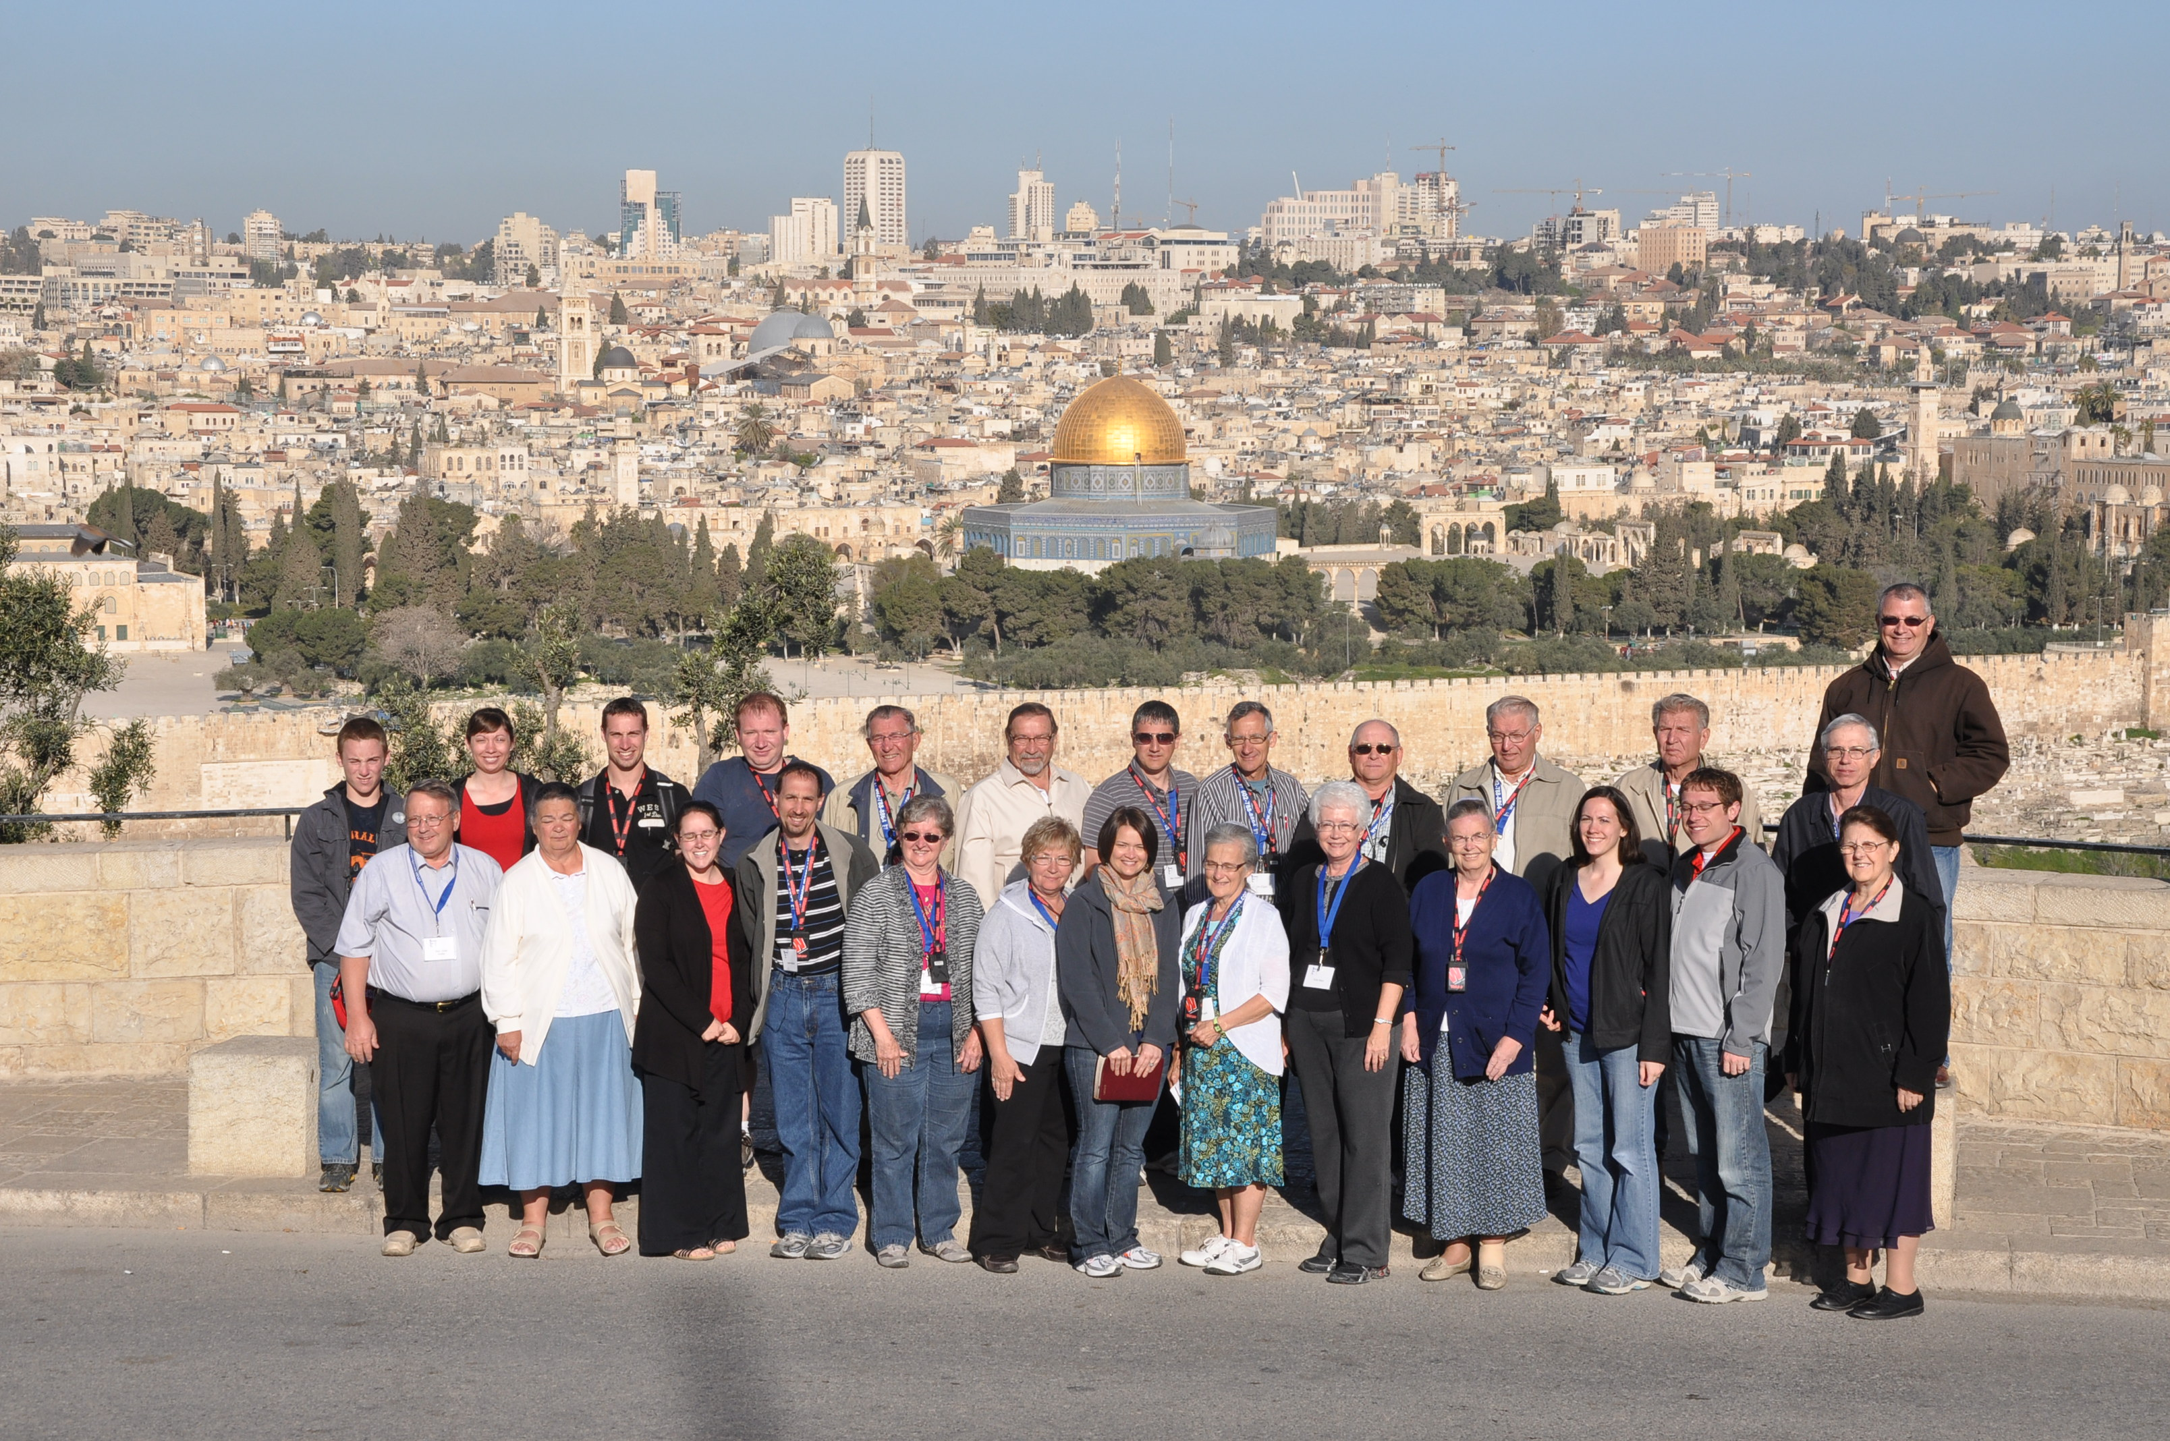
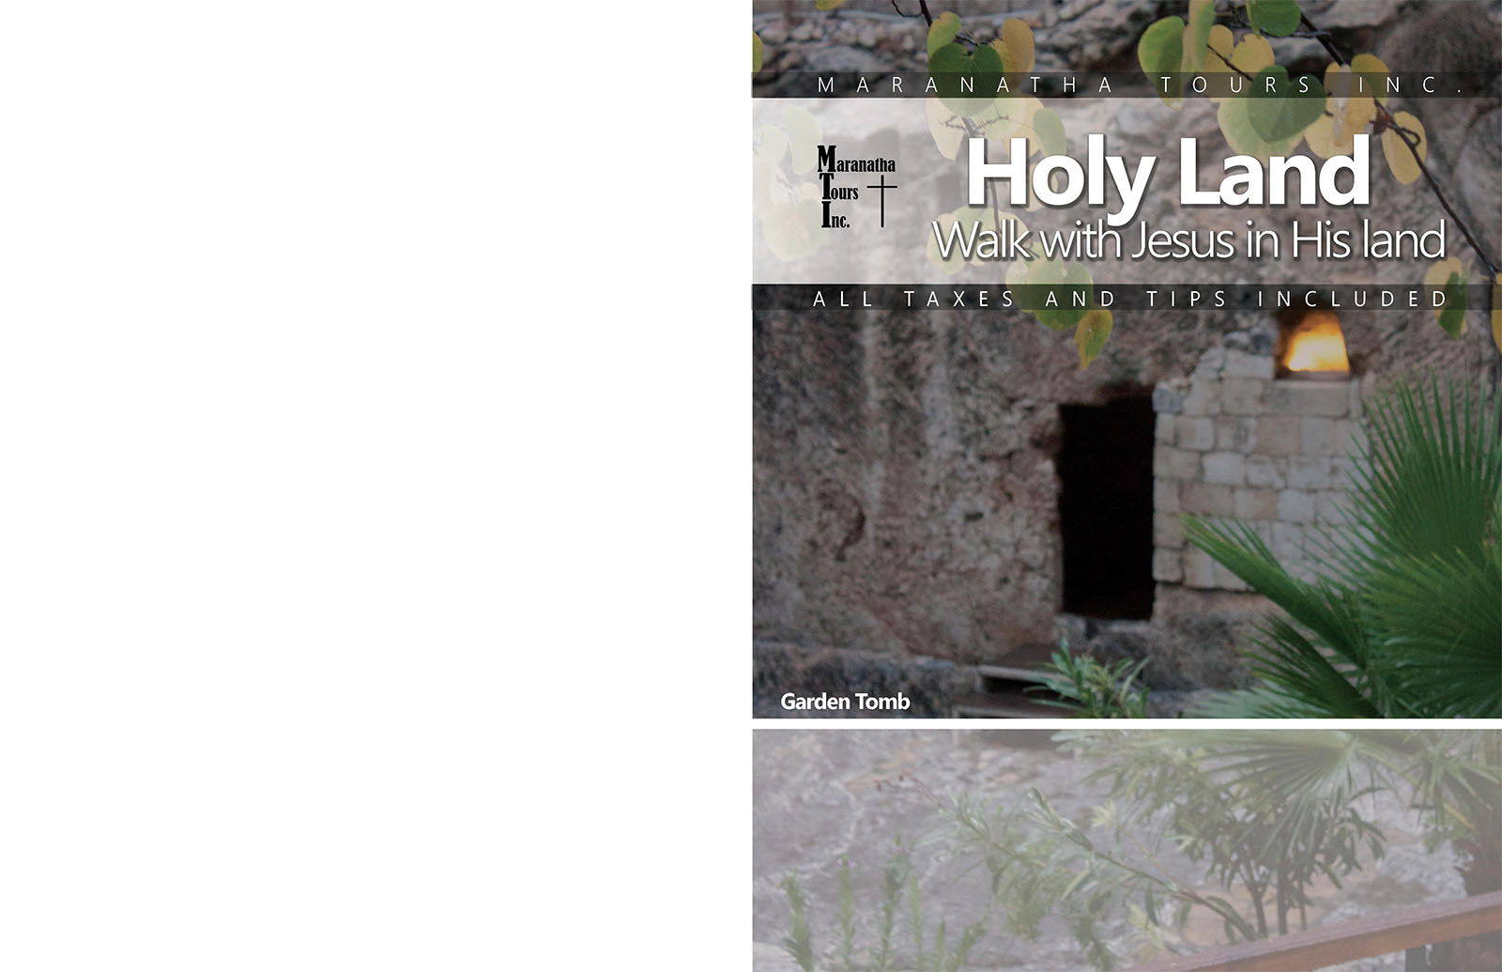
April 9 - 17, 2018
$3,848 from CINCINNATI
(Based on minimum of 30 passengers)

Apr 17 - 20, 2018
Post extension to: ITALY
$1,150 per person
TOUR HOSTS:
Pastor Shane Nickell
First Baptist Church
OFFICE: (606) 546-3636
CELL: (606) 627-8058

ISRAEL BEGINS HERE

DAY 1 - Monday, April 09, 2018
CINCINNATI / TEL AVIV
Today we will meet at Cincinnati International airport for our connecting flights to Tel Aviv via wide-body aircraft arriving the next day. Meals served on board.

DAY 2 - Tuesday, April 10, 2018
TEL AVIV / TIBERIAS
Upon landing we will be met by our representative who will assist us in getting to our modern motor coach. Continue through the largest city in Israel. We proceed to the famous Sea of Galilee where we check into our hotel for dinner and overnight.

DAY 3 - Wednesday, April 11, 2018
MAGDALA / HAZOR/ DAN / CAESAREA PHILIPPI
"The Head of all those Kingdoms" (Joshua 11:10) The Sources of the Jordan. This morning stop at Magdala, one of the oldest Synagogues dating back to the first century AD. Home of Mary Magdalena and was the fishing center where Peter would have brought his catch to be sold or processed. Then on to Chorazin, through the Hula Valley to Hazor, ruins of the powerful Canaanite city destroyed by Joshua and rebuilt by King Jabin and then by Solomon as a chariot city to command upper Galilee.

We continue to the northern limits of Jesus' travel as we cross the River Hatzbani to Dan, where we combine a nature walk beside the Upper Jordan with views of the ancient ruins, topped by the Israelite high place that supported a golden calf (I Kings 12). Then a short drive to Banias (Caesarea Philippi, dedicated to Pan the Greek god of pastures, flocks and shepherds; here Peter made his great profession of faith, recognition of Christ Jesus (Matthew 16). Driving along the foot of Mount Hermon, we ascend onto the Golan Plateau for a magnificent view of upper Israel. Return to the hotel for dinner and overnight.

DAY 4 - Thursday, April 12, 2018
SEA OF GALILEE / CAPERNAUM / BEIT SHEAN
This morning we enjoy a relaxing boat ride on the Sea of Galilee, returning to Nof Ginosar where we will see the New Testament boat New Testament Boat found below the sea. Continue our morning tour with a visit to Capernaum, Tabgha and the Mount of Beatitudes.

In the afternoon we follow the Rift Valley running parallel to the Jordan, along the route Jesus most frequently traveled to Jerusalem. We visit Bet Shean at the foot of Mt. Gilboa, where King Saul was slain, see the evidences of Egyptian, Roman and Byzantine occupations, and view the ancient tel, Roman Theater and church mosaics. Our last stop today will be at the Jordan River where we will have the opportunity to be baptized, then transfer to the hotel in Tiberias for dinner and overnight.

DAY 5 - Friday, April 13, 2018
CANA / NAZARETH / CAESAREA / JERUSALEM
“We are going up to Jerusalem.” (Matt. 20:18). We drive west, stopping in Cana of Galilee where Jesus performed his first Miracle, turning water into wine (John 2). Here we will have the opportunity to renew our wedding vows. We proceed to Nazareth and ascend the Mount of the Precipice at the brow of Nazareth overlooking the Valley of Jezreel, synonymous with Armageddon. We then drive through the valley to the mound of Megiddo, Har Megiddo in Hebrew, which gave its name to Armageddon. We then ascend Mt. Carmel, site of Elijah’s confrontation with the prophets of Baal.

From there we drive towards the Mediterranean coast traveling south along the coastal highway to Caesarea by the Sea. We enter Caesarea Maritima to explore this Roman bridgehead to the east, which became the Christian springboard to the west. After the visit to this ancient harbor, we board our bus, time permitting, we will travel to the Valley of Elah, the site of David's conquest of the giant Goliath and walk that battle ground. Continuing on to Jerusalem where atop Mt. Scopus, we behold majestic Jerusalem. Check in to our hotel for dinner and overnight stay.

DAY 6 - Saturday, April 14, 2018
MASADA / QUMRAN / DEAD SEA / JERICHO
Today we drive to Masada and ascend by cable car to the magnificent ruins of the fortress where, from 70 to 73 AD, Jewish defenders made their last stand in the Judean revolt against Rome. We see the remains of storehouses, cisterns and a sixth-century Byzantine church. Continuing alongside the Dead Sea, 1300 ft. below sea level -- the lowest spot on earth -- we proceed to Ein Gedi where time permitting we will walk the path to see the waterfall in the desert.

This afternoon we continue to Qumran and the caves where the Dead Sea Scrolls were found. We will have a stop for lunch and time at the Dead Sea. We travel to Jericho, the world’s oldest city. From the excavated tel atop the ruins of ancient Jericho we view the lush green Jordan Valley, Elisha’s spring and Qarantal, the Mount of Temptation. We will head up to Jerusalem and return to the hotel for dinner.

DAY 7 - Sunday, April 15, 2018
MT. OF OLIVES / GARDEN OF GETHSEMANE / HERODIUM / SHEPHERD'S FIELDS / BETHLEHEM
"If you, even you, had only known on this day what would bring you peace" (Luke 19:42)
We start the day via the Chapel of Ascension and Paternoster to the Mt. of Olives for an orientation view of Jerusalem and the opportunity of a group photograph overlooking Jerusalem. We then walk the traditional Passion walk. We descend to the church known as Dominus Flevit ("Our Lord weeps"). After viewing the Golden Gate, we walk downhill to Gethsemane, where we take time to meditate on the Gospel text and view the Church of All Nations. Next we visit the Upper Room and the Tomb of King David, enter the Zion Gate and proceed to the Steps that entered the temple and the Southern Wall. It was here that Jesus would have taught the disciples. See a video that shows the temple as it was at Herod's (or Jesus') time.

“I bring you good news of great joy that will be for all the people. Today in the town of David a Savior has been born to you; he is Christ the Lord.” (Luke 2:10-11). We drive south to the region of Bethlehem Bethlehem passing Rachel's Tomb on the outskirts of Bethlehem. We drive to a hilltop for a view of Bethlehem, noting its relation to the rest of the central mountain range, including Jerusalem, as well as to the desert and the area of ancient Moab. This is Herodium, the palace set in a conical mountain built by Herod to mark his tomb. Note the juxtaposition of the two Kings of the Jews. The King Herod buried in great opulence and the King of the Jews born in a humble manger in Bethlehem sitting in the background of the Herodium. We then drive to one of the possible sites for Shepherds' Fields. We continue into Bethlehem itself, walking through the restored old town to the Church of the Nativity and visiting the manger and see the cave of St. Jerome. Time permitting driving south, we visit Solomon's Pools, Jerusalem's main source of water for almost 2000 years. We drive back to Jerusalem for dinner and overnight.

DAY 8 - Monday, April 16, 2018
OLD CITY / VIA DOLOROSA /GARDEN TOMB
“He has risen!” (Mark 16:6) After breakfast we begin our day at the Pool of Siloam (John 9: 6-7). Continue on the Dung Gate, where we walk via the Western Wall, Judaism’s holiest site. From here we can see the Dome of the Rock and the al-Aqsa Mosque, considered the third holiest site of Islam, located on the site of the ancient Temple Mount. Here the first and second Temples once stood. Just to the north we find the Pools of Bethesda (John 5) and St. Anne’s Church. The church is perfectly preserved from the Crusader period – with remarkable acoustics. Continuing on we see Pilate’s Judgment Hall, the Chapel of Flagellation, Lithostrotos, and the Arch of Ecce Homo (Behold the Man). We then follow the Way of the Cross (Via Dolorosa) through the bazaars as far as the Holy Sepulcher. From there we walk from the Christian Quarter along the Arab Souks through the Cardo Maximo and past the Armenian Quarter. Continuing to Mt Zion and to the grounds of a church called Peter in Gallicantu, which affords the best view of early Jerusalem from the west. (Here, the Assumptions Fathers suggest, was the house where the High Priest Caiaphas interrogated Jesus). We board our bus to the Garden Tomb where we will end our day with a special visit and the possibility of having a private communion on the grounds outside the city walls. Return to the hotel for dinner and overnight.

DAY 9 - Tuesday, April 17, 2018
JERUSALEM / TEL AVIV / USA
We transfer to the Ben Gurion airport for our flight home with unforgettable memories to cherish always. Knowing we have walked in the footsteps of Jesus and the early Christians on such a memorable tour will bring new meaning to our Bible reading.

POST EXTENSION TOUR TO ITALY

DAY 1 - Tuesday, April 17, 2018
JERUSALEM / ROME
This morning we will have some time to have a last visit to the old city or just rest and get ready for our flight to Rome. This afternoon we transfer to the airport for our flight to Rome. Upon arrival we will be taken to our hotel for dinner and overnight.

DAY 2 - Wednesday, April 18, 2018
PAUL'S DAY
This morning we will visit the most interesting sites which are linked with the life of the Apostle Paul in Rome, Insula di San Paolo alla Regola. Tradition has it that this is the area for Paul's first visit and house arrest in about 62AD. We visit the Church of Santa Prisca where you can still see the big Doric Capital used by Apostle Peter to baptize Prisca. Next we visit the Catacombs of San Sebastian, located on the Ancient Appian Way. This is where the bodies of Apostle Paul and Apostle Peter where kept during the Christian persecution of Valeriano ( 253 – 260 AD). There is a lot of “graffiti” in Latin and Aramaic in the catacombs and in the Basilica of San Sebastian. Continue on to the Abbey of the Three Fountains, the place of Paul’s martyrdom, where tradition has it that three different springs gushed out at each spot touched when Paul’s head fell down. Next we visit St. Paul Outside the Walls, with the adjoining Basilica where the bones of Paul have recently been found. Return to hotel for dinner and overnight.

DAY 3 - Thursday, April 19, 2018
ROME / TREVI FOUNTAIN / VATICAN / SISTINE CHAPEL
This morning we visit the Vatican Museum and Gallery, Raphael's Rooms with their wonderful frescoes, the Sistine Chapel – where Michelangelo's recently restored masterpieces adorn the ceilings and walls – and Pincio Garden. We continue into St. Peter's Basilicaand view Vatican City.

This afternoon we continue sightseeing of the Colosseum, Trevi Fountain, Pantheon and Navona Square; with its beautiful Bernini’s Fountain of the Rivers. Dinner and overnight at our hotel.

DAY 4 - Friday, April 20, 2018
ROME / USA
After breakfast, we are transfer by coach to the airport , for your return flight to home The end of an unforgettable pilgrimage

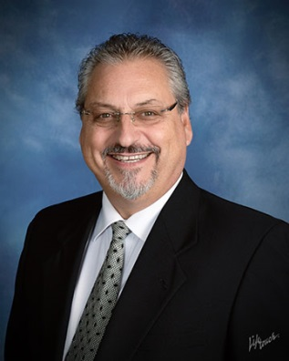
Pastor Shane Nickell

A trip to the land of our Lord is so much more than a "tour" or an interesting sightseeing trip… it is seeing, touching, tasting, experiencing firsthand the land and culture of our Christian faith!

This will be our fifth time leading friends to the Holy Land. On each pilgrimage we have experienced Christ in a personal, exhilarating way that is almost impossible to put into words. We love taking others to walk where Jesus walked and see the places where Jesus taught, prayed and ministered to the people of His day.

Imagine praying at Jesus' birthplace in Bethlehem, taking a boat out on the Sea of Galilee as did the disciples, walking the streets of Jerusalem and partaking of the Lord's Supper in the garden just outside of the empty tomb where Jesus rose from the dead. "He is not here; he has risen, just as he said. Come and see the place where he lay" (Matt. 26:6).

April is a great time to be in the Holy Land… the weather is generally pleasant, 60-80 during the day, and a light sweater or jacket in the evenings. The land is alive with the flowers starting to bloom and everything turning green.

We would love to have you join us on this life changing pilgrimage. Personally experience what you have read and studied in the scriptures as the Bible comes alive for you in God's Holy Land!

Pastor Shane,

Phil 1:3-6

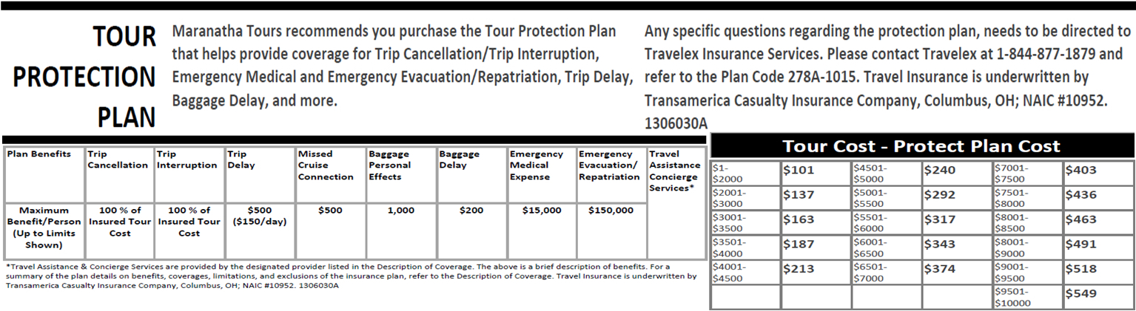

CLICK – SCAN - PRINT
TERMS AND CONDITIONS

ACCOMMODATIONS: First class hotels based on twin occupancy with bath. Single-room supplement totals are ISRAEL $522 and ITALY $114.

MEALS: Unlimited buffet breakfasts (7) and dinners (7) daily in Israel and continental buffet breakfasts (3) and set menu dinners (3) daily in Italy. No meals are provided in USA. Extra charge for coffee, tea or other beverage not included in the menu of the day. If a passenger chooses not to have a meal, there will be no refund for unused meals.

AIRLINE ROUTES & TICKETS: In order to keep prices low, MTI does not guarantee the most direct routing to your final destination. Once “printed” or “issued”, airline tickets cannot be changed or refunded thereafter. Air transportation to/from your destination will be economy class on IATA and ARC carriers utilizing APEX or SUPER APEX non-refundable, non-amendable tickets for groups of 10 or more flying together on entire itinerary. Full payment is due 45 days prior to commencement of travel. If the passenger cancels within 35 days of departure or after air tickets are written (whichever comes sooner), then 100% of airfare will be forfeited by passenger. All airfares are subject to government approval and change without notice. AIR--cost and schedules could change. Please Note: An overnight may be necessary for groups misconnecting on the outbound or return. Airline tickets are issued 30 days prior to departure, seat assignments can be requested but are not guaranteed as tickets are issued in bulk.
ADDITIONAL AIRLINE FEES: You may incur additional airline baggage and optional fees (food, Excess Baggage, Items of a Personal Nature etc...) and will be charged by the airline at check in.

TIPS AND TAXES: Tips to guides & drivers, gratuities to porters, restaurant and hotel servers, fuel surcharges, foreign departure taxes and visas (for US passport holders) are included in the tour cost. (Increases in government taxes, fuel surcharges, gratuities and visas fees are subject to change). The taxes as of print are: ISRAEL $897, ITALY $27 the tips as of print are: ISRAEL $130 ITALY $101 per person.

SIGHTSEEING: By modern motor coach including services of English speaking guides and entrance fees to places included in the itinerary. Where available all groups will be provided with portable listening devices. Passengers are responsible for loss or damage of the device.

NOT INCLUDED: Passport, laundry, wines, liquors, mineral waters and after-dinner coffee or tea, meals not included in the itinerary, room service, sightseeing or services other than those specifically mentioned. Baggage fees and surcharges are different for every airline therefore please contact the airline for specific baggage allowance and fees. Maranatha Tours Inc. is not responsible for these related fees as this is solely the responsibility of the passenger.
TOUR PROTECTION PLAN (optional): Maranatha Tours Inc. recommends you purchase a Tour Protection Plan for Trip Cancellation/Trip Interruption, Emergency Medical and Emergency Evacuation/Repatriation, Trip Delay, Baggage Delay, and more.

PASSPORTS, VISAS: A valid US passport is required for US citizens. If you do not have a passport please contact your local passport office. Passports must be valid 6 months after return date. For all other nationalities please consult the country’s consulate as VISA fees may be different.

TOUR PRICE: Price is based on international tariffs and rates in effect on Date of proposal and is subject to change should there be a revision in AIR or LAND rates prior to payment in full of the tour price. Price is based on a minimum of passengers using double occupancy. In the event that a minimum of passengers does not book the tour within 91 days of departure the agent reserves the right to cancel the tour. You will be notified immediately upon any increase and will have the option of paying the difference or cancelling with full refund. Late booking or changes may result in an additional fee. Maranatha Tours Inc. reserves the right to correct invoices, itineraries, and/or brochures without notice.
PRICE INCREASES: All prices quoted in this brochure are subject to change if not paid in full due to currency fluctuations, fuel surcharge increases, government taxes and fees increases or unforeseen circumstances. You will be notified immediately upon discovery of an increase and will have the option of paying the difference or canceling with full refund.

LAND ONLY: From time to time a tour may be canceled due to not materializing. If you choose to purchase a land only package and arrange your own domestic and international flight independently, Maranatha Tours Inc. is not responsible for any International flight schedule changes. If domestic tickets are purchased by an individual, all penalties and fare differences will be paid by the client.

DEPOSIT AND CANCELLATION: A deposit of $500 per person is required to secure reservations, which will be applied to the price of the tour. The balance to be paid in full not later than 6 weeks prior to departure of the tour. Thereafter, a $100 late payment fee will be assessed. Reservations made within 30 days of departure are subject to $75 late reservation charge. All cancellations must be in writing by letter, fax or e-mail to Maranatha Tours and will be in effect on the date of receipt by Maranatha Tours. There is no exception to cancellation fee. Any exceptions must be in writing from Maranatha Tours, Inc. Air penalties are not part of the percentages below and vary based on the airline policy at the time of ticket issue. Returned checks incur a $30 NSF fee.
• 91+ Days Prior: No penalty of deposit
(Except for $100.00 per person administration fee plus any airline fees)
• 90-61 Days Prior:
($500 for international tour, $700 for international tour and cruise plus any airline fees)
• 60-46 Days Prior: 40% of tour cost
• 45-31 Days Prior: 65% of tour cost
• 30-16 Days Prior: 85% of tour cost
• 15 Days Prior or less: 100% of tour cost

ITINERARY CHANGES: If itinerary changes necessitate extra overnights, you will be charged $90 to $125 per night per passenger; single rooms- $130 to $150 per night. Meals for extra nights are not included.

RESPONSIBILITY AND LIABILITY: Land arrangements including surface transportation: Maranatha Tours, and the participating Tour Operators operate the land tours offered under this program only as agents of the railroads, car rental contractors, steamship lines, hotels, bus operators, sightseeing contractors and others which provide the actual land arrangements and are not liable for any act, omission, delay, injury, loss or damage or non-performance occurring in connection with these land arrangements. International air carriers and other IATA carriers, steamship lines and other transportation companies whose services are featured in these tours are not to be held responsible for any act, omission or event during the time passengers are not on board their conveyance. The passage contract in use by these companies when issued shall constitute the sole contract between the companies and the purchaser of these tours and/or passage. The tour operator reserves the right to change the itinerary, delete or substitute sites when tour operator feels it to be in the best interest of the tour. Maranatha Tours does not provide additional assistance to any passengers that have physical or mobility limitations as tour itineraries require full mobility. Please advise Maranatha Tours if you have any limitations that may impact your tour.

CHANGE FEE: All changes not received in writing by Maranatha Tours at least 45 days prior to departure will incur a $75 change fee per person for each revision (that is in addition to any other charges per revision once the basic or pre/post tour package has been confirmed).

LAND ARRANGEMENTS: The tour operator reserves the right to change the itinerary due to emergencies. If itinerary changes necessitate extra overnights, you will be charged $90 to $125 per night; single rooms- $130 per night. Meals for extra nights are not included.

DEVIATIONS: Deviations will incur a $125 fee, plus any other additional costs associated with services included in the basic or pre/post tour. Transfers are included in our group round-trip programs, passengers who deviate or purchase land only packages will be responsible for arriving and leaving independently and must transfer at their own expense.

CREDIT CARDS: All prices already include a 5% discount for payment by cash, check or money order.

EXCHANGE RATE FLUCTUATIONS: Foreign currency exchange rates fluctuate daily. For example, in 2012, Euro rates versus the US Dollar fluctuated from a low below 1.10 to almost 1.70 (meaning that one Euro cost $1.10 to $1.70 US). It is very difficult to set the price of a tour when we cannot predict what exchange rates will do. We price our tours at $1.10 = € 1 and adjust for fluctuations at final billing. If the rate drops below the original rate, we pass the savings on. If rates increase, we must pass those costs on.
https://maranathatours.com/product/Nickell-Apr-2018-ISRAEL
Maranatha Tours, Inc.
18428 N. 42nd Place
Phoenix, AZ 85032
Phone: (602) 788-8864
Email: MTI@maranathatours.com
www.maranathatours.com

Make checks payable to “Maranatha Tours, Inc.” and mail to the above address.

***(ALL PRICES SUBJECT TO CHANGE WITHOUT FURTHER NOTICE)
REGISTRATION FORM

Enclosed is my/our $____________ deposit ($500 per person)

Legal Name: _______________________________________

___________________________________________
First/Middle/Last (As it appears on your passport)

Street Address: __________________________________________

City: ________________State: ______Zip: ______________

Phone: _____________ Work Phone:____________________

Email Address: ____________________________________

Birth Date: ______/_____/______ Age______ M F

Birth Date: ______/_____/______ Age______ M F

Emergency Contact: __________________ Relationship_________

Please try to accommodate me with a Roommate
I do request a single room @ ISRAEL $522 and ITALY $114.
Travel Protection Plan (MUST SELECT ONE)
❑ I/We (OPT IN) (accept) the Tour Protection Plan
❑ I/We (OPT OUT) (decline) the Tour Protection Plan

Signature:______________________ Date: _____

Please Sign Me/Us up for:
Post-Extension to ITALY

Reserve domestic air from______________________

Pastor Shane Nickell - 180418
Departure Date April 9, 2018

By signing below, I certify that I have read the "Fine Print",
understand its content, and agree to its terms including but
not limited to additional fees that may apply if full payment
has not been received.

Signature:______________________ Date: ____

Signature:______________________ Date: ____

minors require parental or guardian signature
For further information please contact:

Shane Nickell
First Baptist Church
201 North Main Street
Barbourville, KY 40906
pastorshane.fbc@gmail.com
OFFICE: (606) 546-3636
CELL: (606) 627-8058

