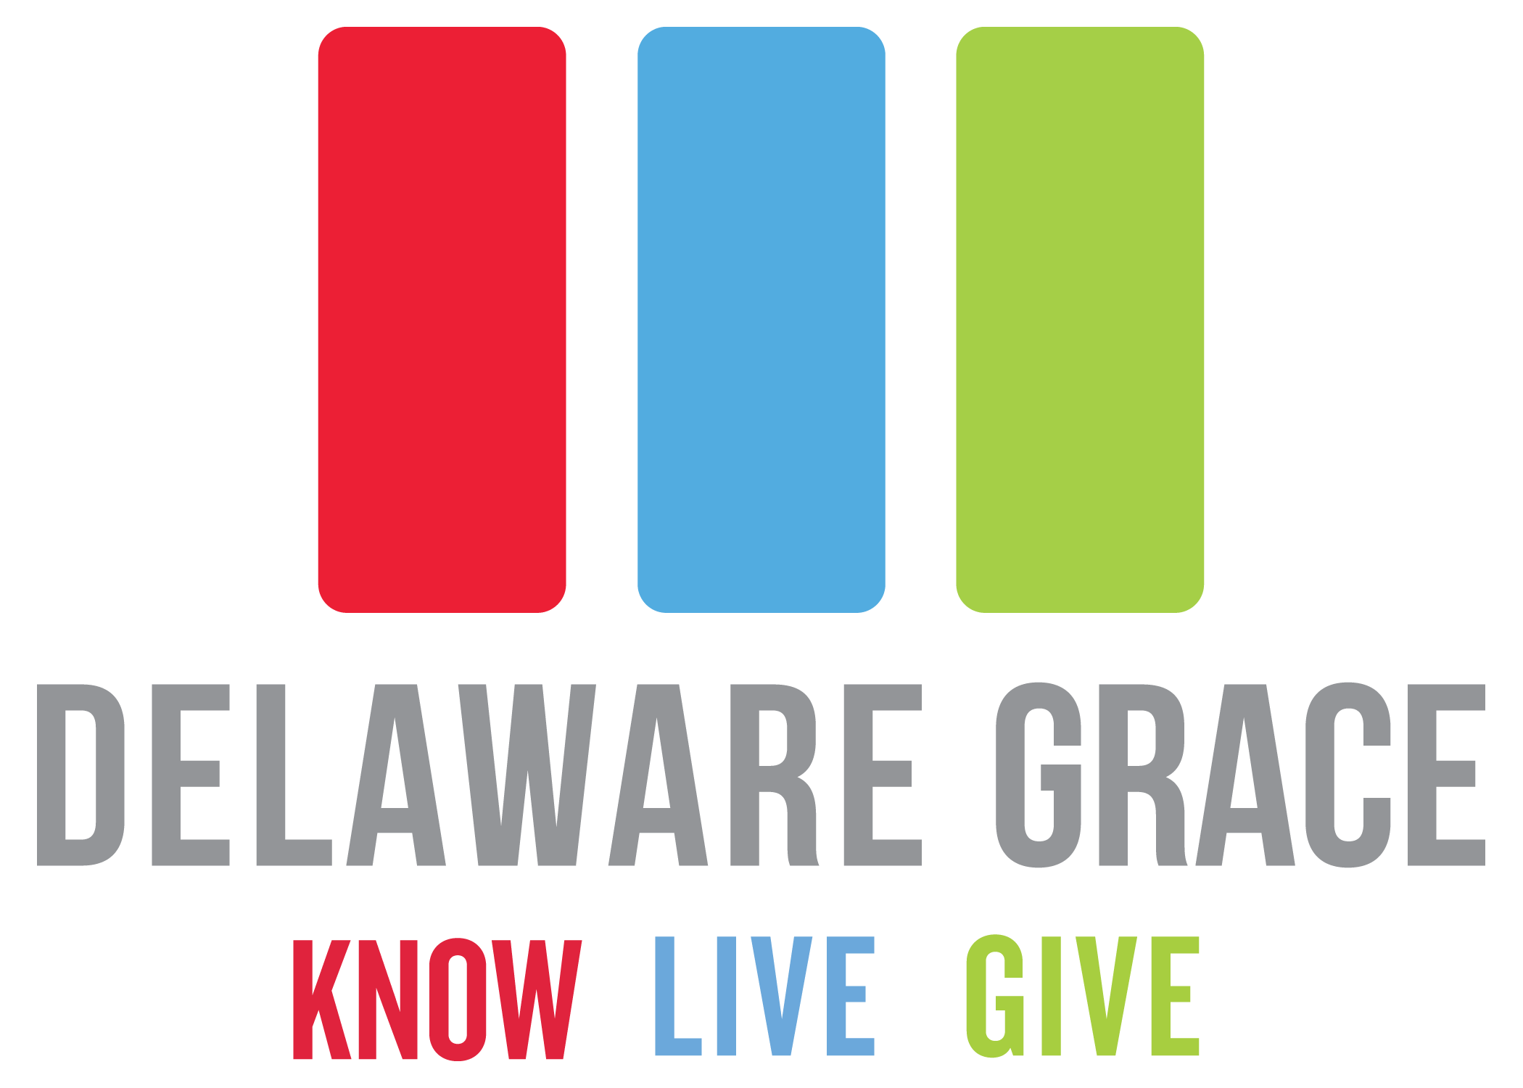  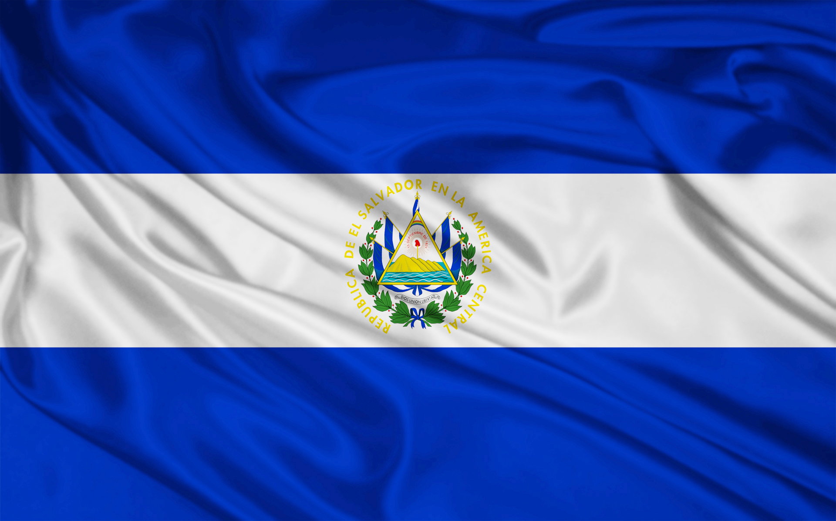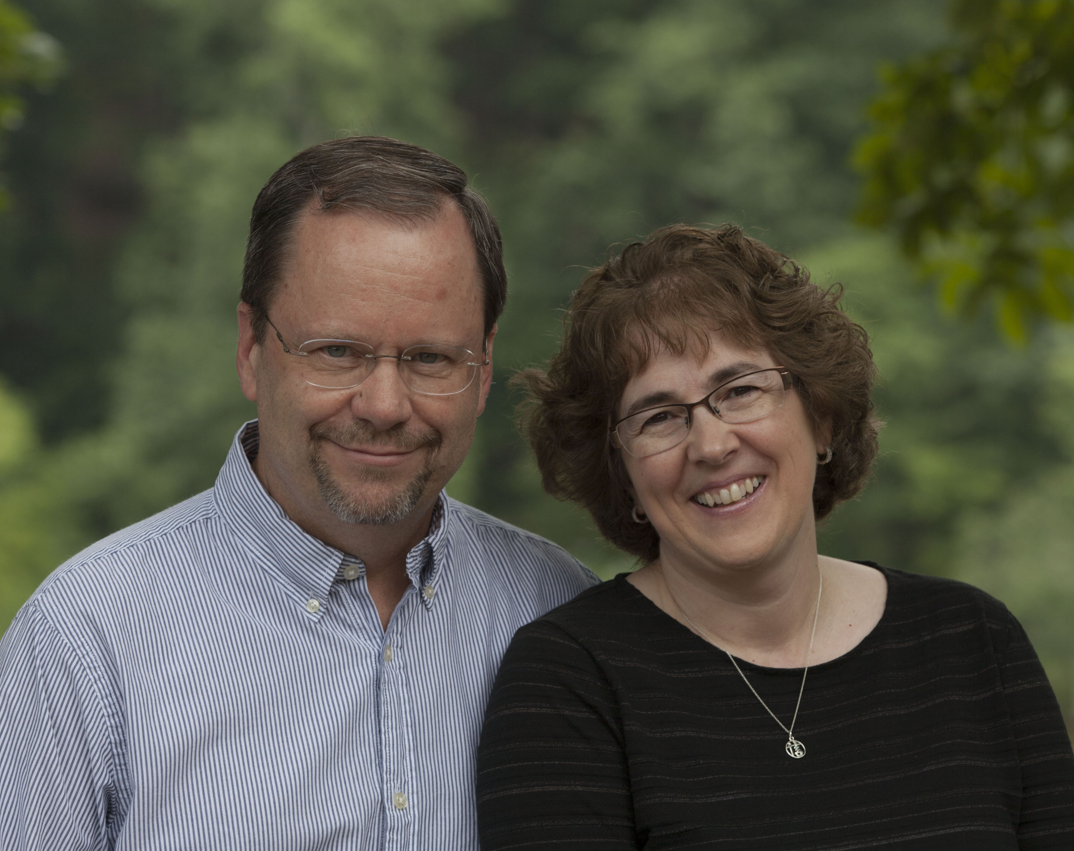

The We Care Team will be hosting a workshop @ 9am on Saturday, November 11th. They are in need of anyone that would be willing to come participate as they make pillows for their ministry! If you have your own sewing machine, please feel free to bring it. If you have no sewing experience, we would still love to have your helping hands at the workshop. Lunch will be provided so please feel free to come lend a helping hand and then stay for lunch and a little socializing with the other ladies. We look forward to seeing you there!

**We Care Workshop:**

“Leading people into a growing relationship with Jesus Christ.”

November 2017

DGNews

**Communion:**

On Sunday night, November 19, @ 6pm, we will join together at DG for our Thanksgiving Communion service. It will be a great night of sharing, singing, and remembering the death and resurrection of Jesus! There’s not a better place to have our hearts and minds focused as we prepare for Thanksgiving with our family and friends. Our threefold communion looks at the past, present, and future as we remember what Christ did, is doing, and will do for those who trust in Him!  Make plans to join us!

We are excited to announce the next Men’s Breakfast on November 11th @ 7:30am. Please make sure to extend invites to family, friends, and neighbors to come be a part of this get together. Kyle Snyder will be our guest speaker that morning and you won’t want to miss it! Kyle is the youngest Olympic wrestling gold medalist, youngest World Champion in American wrestling history, and a NCAA champion. Delaware Grace is looking forward to hosting him and spending some time listening to him share his heart for the Lord. Don’t miss out! You can sign-up to attend online @ delawaregrace.org today.

**Men’s Breakfast:**

Discover Grace class is the first step to membership. If you’re new to Delaware Grace or if you’ve been attending for a long time and haven’t made it to our Discover Grace class, we encourage you to go on November 8th! Class will be in the prayer room @ 6:30pm. Please come hear what Delaware Grace is all about in terms of vision, history, mission, belief, and how you can be involved. It is also a great opportunity for our staff to get to know you. We would love to talk to you and answer any questions that you may have about Delaware Grace.

**Becoming a member @ Delaware grace:**

Calendar of Events:

Nov. 1st – J.A.M. & Jr. J.A.M. 6:30pm

Common Thread 6:30pm

Men’s Bible Study 6:30 & 8:30pm

*(also on Nov. 8th, 15th, & 29th)*

Nov. 2nd – El Salvador Prayer Group 5:30pm

(*also on Nov. 16th)*

Nov. 2nd – Hope & Healing 6:45pm

180 Men’s Ministry 6:45pm

(*also on Nov. 9th, 16th, & 30th)*

Nov. 5th – Daylight savings time

Nov. 5th – Middle School Boys Class 9am

Adult Bible Fellowship 10:45am

College Life Group 5pm

*(also on Nov. 12th, 19th, & 26th )*

Nov. 6th – Men’s group 7pm

Basketball Open Gym 7pm

*(also on Nov. 13th, 20th, & 27th)*

Nov. 7th – Calico 9:30am

Tapestry 6:30pm

*(also on Nov. 14th & 28th )*

Nov. 8th – Discover Grace Class 6:30pm

Nov. 19th – Communion 6pm

Nov. 23rd – Thanksgiving

Nov. 29th – Baptism Class 6:30pm

Our El Salvador missions team is getting ready to head out on their trip to visit our brothers and sisters at Iglesia de Dios in January! Before they are able to depart, they need our help to make fundraising a success. They have planned a number of wonderful events ranging from babysitting nights to restaurant fundraisers. Thank you to all who have already participated in the Opa night and t-shirt sale fundraisers! We are thankful for your support in helping make these trips a reality. Below, please find the list of upcoming events and dates for your calendar. We hope to see you there!

November 5th Bake Sale –Stop by the table and grab some delicious baked goods before or after each service.

November 6th Buffalo Wild Wings – Grab some lunch, dinner, or a late night snack at the Delaware BWWs any time between 12pm-12am. Just tell your server that you’re with Delaware Grace and the team gets 10% of the funds.

November 17th Babysitting Night @ DG – We would love to watch your kiddos for you from 5:30-10pm. Cost per child will be $20 with a $5 off each additional child from the same family registered. Register your kids on our website for the first of two babysitting nights! There will be food, crafts, games, and a movie.

December 9th Spaghetti Dinner/Night with El Salvador – Join us @ Delaware Grace as the team leads us through an evening talking about our church partnership, Iglesia de Dios, and Compassion International. There will be a spaghetti dinner and tax-deductible donations will be accepted.

December 15th Babysitting Night @ DG – Our babysitting fundraisers were a hit in 2016 so we will be offering two this time around. Let us watch your kiddos while you go out on date night, run some errands, or just relax! The evening will be from 5:30-10pm and the cost will be $20 per child with $5 off each additional child registered from the same family. Make sure to register your kids @ delawaregrace.org!

December 18th Buffalo Wild Wings – Grab some lunch, dinner, or a late night snack at the Delaware BWWs any time between 12pm-12am. Just tell your server that you’re with Delaware Grace and the team gets 10% of the funds.

**El Salvador Team fundraisers:**

Dave & Sue Guiles work with Encompass World Partners, which is based in Atlanta, GA. Dave has been with Encompass since 1987 and now serves as Executive Director. As passionate, courageous servants, Encompass invests in others through dedicated mentorship. They seek to mobilize individuals and churches to fulfill their roles in the Great Commission.

Encompass World Partners is on mission to glorify God and make Him known among the nations by equipping individuals. Dave & Sue work to prepare and deploy cross-cultural workers for evangelism, church planting and leadership training to currently 228 people groups, in 34 countries, on 5 continents. Guiles is passionate about seeing all nations and races come to salvation and worship Jesus Christ. He is currently working to prepare Encompass and other organizations to accept and encourage the new generation of church leaders.

The Encompass family continues to focus on seeking out and using innovative means to share Christ with those who have not heard, gather new believers into community, and train leaders so an indigenous church planting movement will flourish. They also commit to showing Christ’s love to those in need. Through crisis response, integrated medical care, and sustainable community development, they seek to minister to the needs of our brothers and sisters and to “do good to all people.”

**October global Partners: Hand in hand schools C.A.R.**  **:**