00

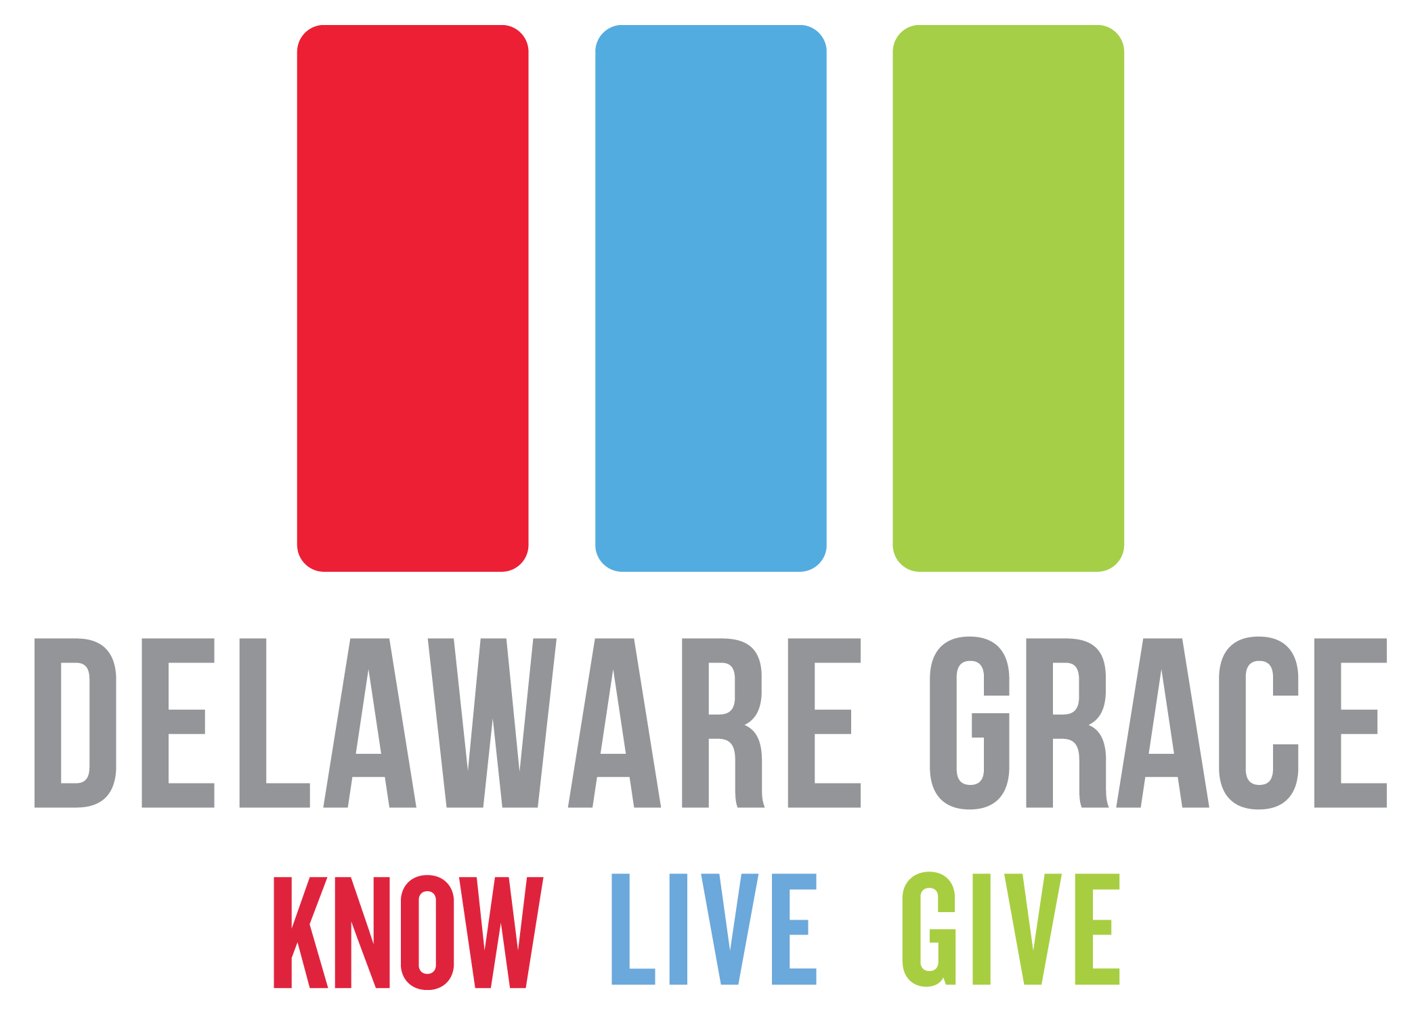

DGNewsws





The summer months are upon us! Along with all of the awesome fun that our kids will have this summer, Vacation Bible School will also be in full swing and better than ever! We just wanted to remind you that VBS this year is going to be July 29th – August 2nd from 6:30pm-8:00pm. Stay tuned for more information about VBS and also for ways that you can serve and be involved!

Mother’s Day is right around the corner! In honor of Mother’s Day and all of the wonderful mom’s in our community, the youth group is hosting a Mother’s Day Brunch here at the church, Sunday May 12th at 8:30am. Tickets are $5 a person, so Dads and kids, treat Mom to a great breakfast and help our students raise money for trips and conferences. The menu will be pancakes, eggs, sausages, fruit and yogurt.

**VBS - Save The Date**

**Graduation Recognition Sunday**

**Discover Grace**

We are still accepting any and all baby pictures as well as recent/ senior pictures from those of you who are graduating for the slideshow in our Graduation Recognition Sunday coming up on May 19th. Along with the pictures, let us know where you graduated from, your plans for next year (college, workforce, etc.), and anticipated major in college. All submissions should be sent to Pastor Sam at sammoore@delawaregrace.org before May 15th! We extend an early congratulations to all of our graduates from Delaware Grace!

Are you somewhat new to Delaware Grace and interested in learning more? Do you feel that maybe you need to get more connected, whether it’s a small group or a serving team? Are you feeling led to take the next step toward membership at DG? If you answered yes to any of these questions, Discover Grace is the class for you. We’ll meet on Wednesday, May 8th from 6:30-8:00pm. If you have any questions, please contact Pastor Dave at davepacheco@delawaregrace.org.

**Mothers Day Brunch**

Calendar of Events:

May 1st – Men’s Group 8pm

*(also on May 8th, 15th, 22nd & 29th)*

May 2nd – Men’s Group 6:30am

*(also on May 9th, 16th, 23rd & 30th)*

180 Recovery for Men 6:45pm

*(also on May 9th, 16th, 23rd & 30th)*

Infidelity Care for

Betrayed Women 6:45pm

*(also on May 9th, 16th, 23rd & 30th)*

May 5th – Baptism Sunday

Youth Group 7pm

*(also on May 12th, 19th & 26th)*

May 6th – Refit 6:30pm

*(also on May 13th, 20th & 27th)*

Men’s Group 7pm

*(also on May 13th, 20th & 27th)*

May 8th – Discover Grace 6:30pm

May 10th – Compassion Letter Writing 6:30pm

May 11th – Venture Parents Meeting 10:30am

May 12th – Mother’s Day

Mother’s Day Brunch 8:30am

May 18th – Church Work Day 9am

May 19th – Grad Recognition Sunday

Grace Kid’s Appreciation

Breakfast 8:30am

May 19th – 25th – National Law Enforcement

Recognition Week

May 2019

“Leading people into a growing relationship with Jesus Christ.”

**Law Enforcement Recognition Week**

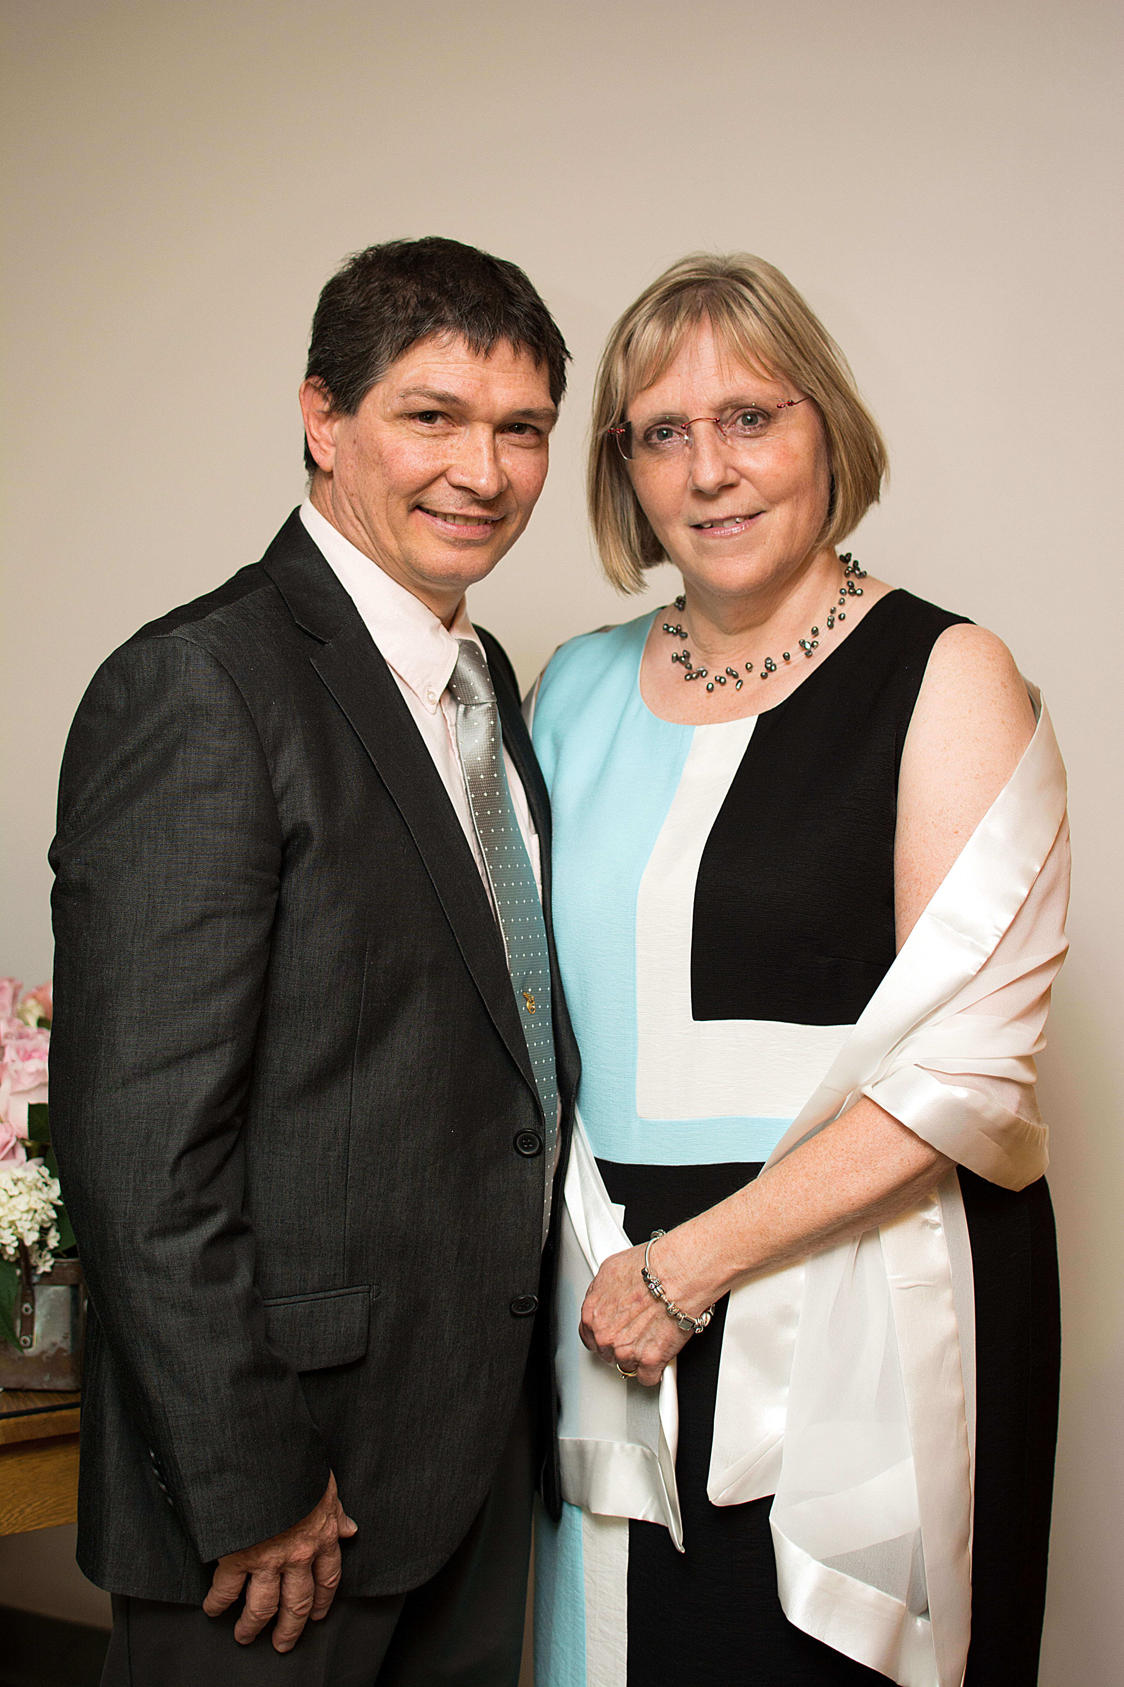

We are still looking for volunteers that would be interested in helping out and investing in the lives of the young ones here at Delaware Grace on Sunday mornings. If you love crafts, games and showing the love of God to the kids of our community then this is an opportunity for you. If you are interested in being a part of this ministry, please contact Billie Lang at billielang@delawaregrace.org.

**Grace Kids Volunteers**

Coming up on May 11th, we have a Venture Parents Meeting at 10:30 here at the church. This will be a wonderful opportunity for the parents of current students and parents of student’s not yet involved with Venture (including current 5th grade parents) to come and get information about upcoming trips this summer, Venture Institute, and bonfire bible studies. This will also be a great time to ask Pastor Sam about ways to get involved as a parent with Venture Student Ministries. We look forward to seeing you there!

**Food Collection Program**

The collection of PB&J so far this year has been an incredible success! We appreciate all who have made donations so far! On May 12th, we will be putting a hold on the PB&J collection until August, so if you still have some donations at home, be sure to bring those in before that Sunday!

**Venture Parents Meeting**

All hands on deck! Coming up on Saturday, May 18th we will be having a church work day, where we as a church family can come together and show the Delaware Grace Church building some love. We will be meeting here at the church at 9am and working on any projects around the building for some spring cleaning until noon. If you have any questions regarding what projects we have in mind or if you have any supplies that you’d like to bring, please contact the church offices at either (740) 363-3613 or questions@delawaregrace.org.

**Church Work Day**

From May 19th – 25th we are celebrating National Law Enforcement Week. For those of you who are/ have served protecting through law enforcement, we thank you. In preparation for National Law Enforcement Week, we will be collecting individual or packs/cases of snack items such as candy, energy and protein bars, trail mix, bottled drinks like water, Gatorade, propel, etc., and thank you cards. This is our way as a church to say thank you to our local law enforcement. There will be a collection box in the lobby where you can drop off your donations up until May 12th, so make sure that you bring in anything that you may want to share before then!