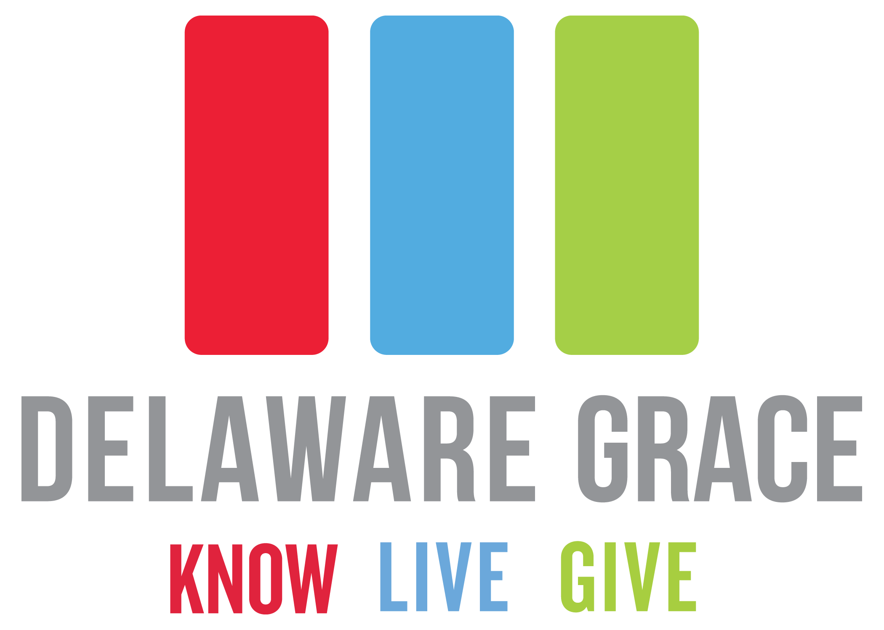  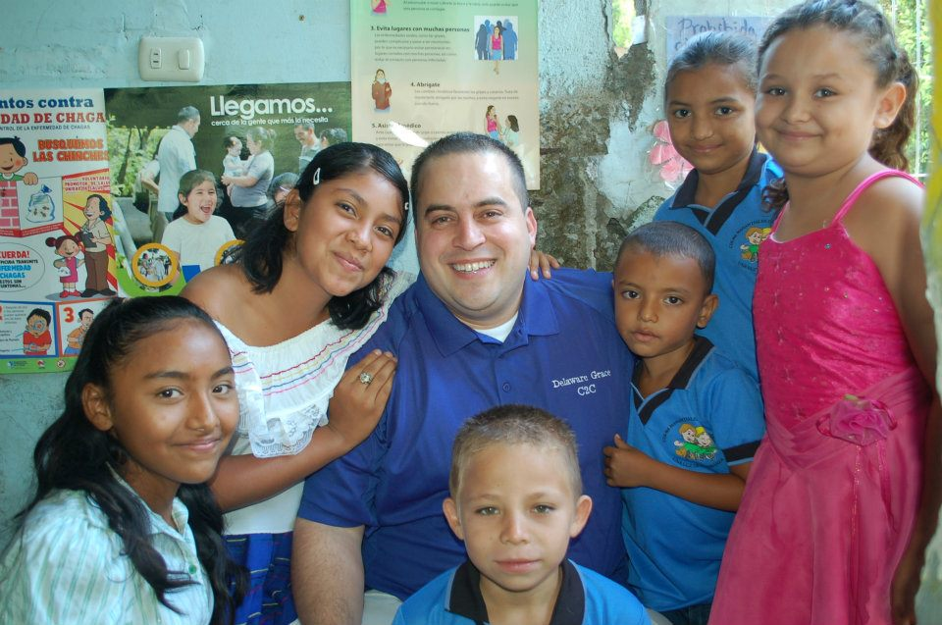

Calendar of Events:

Dec. 3rd – Middle School Boys Class 9am

*(also on Dec. 10th & 17th)*

Dec. 3rd – Secret Sister Party @ 6pm

Dec. 4th – Youth Group 7pm

*(also on Dec. 10th & 17th)*

Dec. 4th – Men’s group 7pm

*(also on Dec. 11th & 18th)*

Dec. 4th – Basketball Open Gym

*(also on Dec. 18th)*

Dec. 5th – Calico 9:30am

Tapestry 6:30pm

*(also on Dec. 12th )*

Dec. 6th – J.A.M. & Jr. J.A.M. 6:30pm

Common Thread 6:30pm

*(also on Dec. 13th & 20th)*

Dec. 6th – Men’s Bible Study 6:30 & 8:30pm

*(also on Dec. 13th, 20th, & 27th)*

Dec. 7th – El Salvador Prayer Group 5:30pm

(*also on Dec. 21st)*

Dec. 7th – Hope & Healing 6:45pm

180 Men’s Ministry 6:45pm

(*also on Dec. 14th, 21st, & 28th)*

Dec. 10th – Daycare Concert @ 3pm

Dec. 11th – El Salvador Spag Dinner @ 6pm

Dec. 15th – El Salvador Babysitting @ 5:30pm

Dec. 17th – Birthday party for Jesus @ 9am

Dec. 24th – Christmas Eve Services @ 4 & 6pm

*( no morning services)*

Dec. 31st - One family-style service @ 10am

**Winter camp:**

Save the date! We’re happy to announce that Winter Camp is scheduled for Feb. 23rd – 25th next year. All students in 3rd-5th grade are invited to attend. Make sure to mark your calendars and start inviting friends now. The theme this year will be the Olympics to coincide with the coming winter games. Students can be prepared to hear a wonderful speaker, sing songs, play games, and learn more about Jesus! Be on the lookout for cost and other details coming soon. Registration for camp will be open starting on January 3rd. Mark your calendars and claim a spot!

**Church budget vote:**

**Angel tree:**

It’s the most wonderful time of the year! Be sure to stop by our Angel Tree in the lobby and choose a very special child that you can bless this season. Most of our angels are being served through Jobs and Family Services in Delaware County. Angels will be available December 3rd & 10th and gifts will need to be returned by December 17th. Please DO NOT wrap gifts. Instead, place them in a plastic bag with the angel attached at the top. Contact Jeanne Mason @ 740-363-3613 with any questions!

Our elders have prayerfully been working on our budget for the coming year. On December 10th, a copy of the proposed budget will be available for everyone. A member meeting will take place after 2nd service on December 17th and everyone is encouraged to attend. December 31st will be our budget vote. Members are welcome to vote absentee if they are unable to be in attendance on the 31st. Thank you for being invested in God’s financial vision for Delaware Grace!

**Kalahari:**

We are excited for our teens to head to Kalahari during January 5-7th! Please be in prayer for them as they travel, learn more about Jesus, and spend time fellowshipping with one another. We look forward to hearing all about their time spent learning and growing in their faith!

Make plans to invite family and friends and join us for Christmas Eve and New Year’s Day! We will be having services @ 4 & 6pm on Christmas Eve. Please make note that there will be **no morning services** on 12/24! On New Year’s Day, we will be having one family-style service @ 10am.

“Leading people into a growing relationship with Jesus Christ.”

December 2017

DGNews

**Christmas Eve & New year’s Day Services:**

There are two big upcoming El Salvador Team fundraisers to put on your calendars! The first will be the El Salvador spaghetti dinner on Monday, December 11th, @ 6pm. Please join us for a delicious spaghetti dinner and a presentation about our partnership with Iglesia de Dios and Compassion sponsorship. Invite friends & neighbors who are not familiar with our partnership to attend with you and your family. The second event will be a babysitting night on Friday, December 15th, @ 5:30pm. This will be a perfect opportunity for parents to drop off their kiddos for a fun evening of crafts, games, a movie, dinner, and fun! Take the evening to go out on a much needed date night, get some Christmas shopping done, or just relax for a few hours without your little ones. Thank you in advance for investing in our partnership!

In addition to our El Salvador Team, our Daycare is currently fundraising for new transportation. They will be holding a Chinese auction in conjunction with their Christmas concert on December 10th @ 3pm. If you are interested in donating gift cards, homemade items, crafts, or new items for the auction, please contact Shelly Ward @ 740-363-3613. A bake sale will take place the same day and all donated baked goods are welcome! If you’d rather just come to participate, tickets will be on sale starting the 10th and winners will be announced @ noon on Friday the 15th. Tickets will be $1 each, $5 for 6, or $20 for an arm length. Thank you for loving and supporting our Delaware Grace Daycare!

2017 is coming to a close and we are beginning to look ahead at the endless possibilities and opportunities that 2018 will have to offer. Many of us are deciding on resolutions and things we would like to accomplish or change in the New Year. As you look at your calendars and evaluate your schedules, we encourage you to explore joining a life group or volunteering on a ministry team if you are not already connected. Both life groups and ministry teams are a life-giving and vital part of Delaware Grace and personal growth individually in your relationship with Christ. We are made to be in fellowship with one another as we go through life. We are also made to reach out and be the hands and feet of Jesus to others. Please visit delawaregrace.org to look at our Life Groups (connect tab) and ministry opportunities (serve tab). If you have additional questions, please feel free to call the church office @ 740-363-3613. Let’s make 2018 the best year yet!

**New year, New commitments:**  **:**

Our Impact Partner for this month is our partner church in El Salvador, Iglesia de Dios! We have partnered with our El Salvadoran family since 2011. Since then, we have taken four trips to meet them, learn, and grow together in faith and relationship. Being church partners means far more than offering our western ideas and finances. Through our partnership with Iglesia de Dios and the people there, we have been able to share ideas, thoughts, prayers, triumphs, and struggles. They are a blessing to us and we are thankful to be doing God’s work with them in different parts of the world! As you pray, please keep in mind all of our beautiful friends there. Pray for God to continue to move in mighty ways throughout their church and community. Praise God for bringing such a beautiful church and partnership to us.

As many of you already know, we have a team of twelve people that will be visiting Iglesia de Dios. Our team departs on January 24th and will be spending the week with our sponsored children and all of our El Salvadoran brothers and sisters. Please be praying for health, safety, smooth travel, meaningful conversations and interactions, and that God’s plan would play out perfectly along the way!

One of the blessings of this partnership is the opportunity to sponsor kids through Compassion International. Our partner church operates a Compassion Project where over 300 kids develop life skills, get an academic education, learn about Jesus Christ, and receive necessary medial attention. This Project is a huge part of our partnership and we’re humbled to be used for God’s kingdom in this way.

If you’ve not made the decision yet to sponsor a child from Iglesia de Dios, or any other area of the world, please consider it! You can visit compassion.com form more information on sponsorship and what that means. You can be making a difference and change lives today!

**december global Partners: iglesia de dios**  **:**

**El Salvador Team & daycare fundraisers:**