Monthly Publication Volume 4, Issue 9 April, 2017
Our Mission: Love God, Love & Serve Others, Make Disciples of Jesus Christ

THE ANNOUNCER is a publication of Christ Church United Methodist, 5109 Washington Ave., Racine, WI 53406
Christ Church United Methodist - Phone 262-632-1607, Fax 262-632-1609

www.christchurchracine.com, E-Mail address: christchurchracine@tds.net
We let people at a local laundromat know Christ Church cares about our community by giving out bags of quarters to help pay for their laundry.

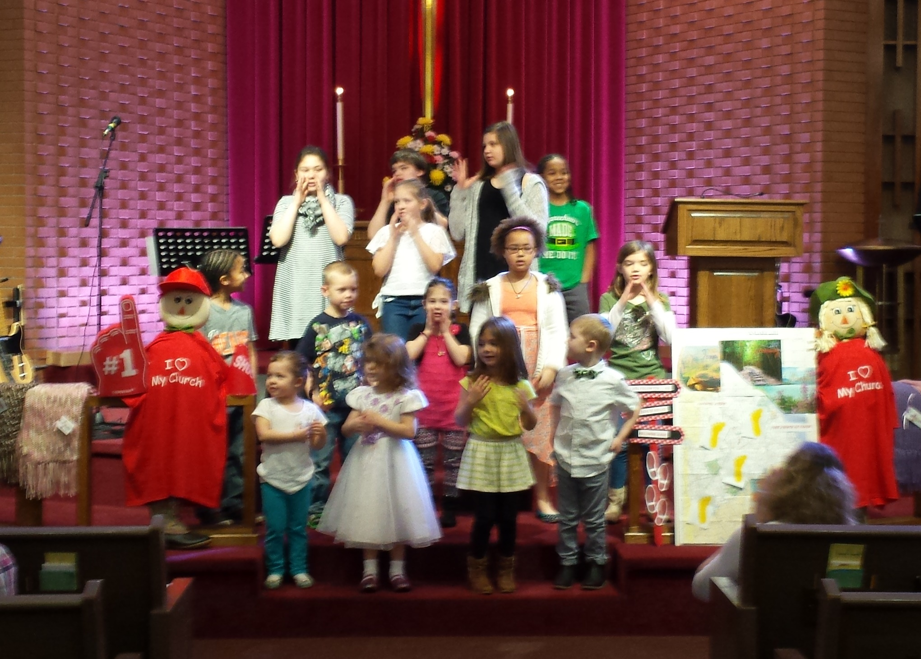

Children from our Kid’s Club youth group offered a song in worship to praise God and remind us of God’s love for us all.

Easter Egg Hunt April 1, 2:00-4:00 p.m.
Families are invited to bring kids ages 6 months-10 years old to travel the bunny trail and collect eggs for a candy prize. Games, Crafts, and food for purchase will be available.

Easter Fest V.B.S. April 8 1:00-3:00 p.m.
There will be crafts, games, and more as we learn about Jesus resurrection.

Worship Services
Typically two styles of worship, Traditional at 9:00 a.m. and Contemporary at 10:30 a.m.
Communion is typically offered on the first Sunday each month. Professional childcare is offered during each worship time. Plan to stay or come early for refreshments and fellowship between services. Don’t forget to wear your name tag! Maundy Thursday 7:00p.m. April 13 & Good Friday 7:00 p.m. April 14

Praise Reports

We raised funds to support a service dog program for Veterans to help assist them and thank them for their service.

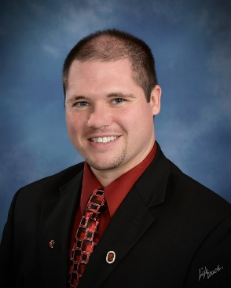
From the Pastor’s Desk

In April we conclude the Lenten season which encourages us all to reflect and pray about our discipleship so that we don’t live as just fans but committed followers of Jesus. Some of the ways we live out our commitment and grow closer with God is through the disciplines of worship, daily prayer, Scripture reading, giving, fasting, and areas of service in the church or community. If each of us seek to grow in and live out our faith not only will we experience the joy of true life, but those around us will, too, as we connect people with God’s love through our individual living and together through the ministries of the church.
As we seek to move into that vision, we are encouraged with the Easter story this month. As Easter approaches once again we are brought into remembrance of God’s great love shown through the life, death, and resurrection of Jesus Christ. In these events, Jesus shows that God is love and provides for the forgiveness of our sin so that we can live life in harmony with God and each other. That is the reason why Good Friday is called “Good.” The Good News of Easter is that, where the world thinks death is the end, we discover that Jesus destroyed the power of sin and death! 2 Timothy 1:10 declares that “Jesus has destroyed death and has brought life and immortality to light through the gospel.” Those who repent of sin and receive Jesus as Lord and Savior can look at the empty tomb and find the power to be freed from sin and fear death no more, because just as Jesus promised to rise Himself, He promises to give new life and raise us also!
In His final words on the cross, Jesus cried out, “It is finished!” That statement reminds us that God has done the work for us and in Jesus the payment for sin is finished. In John 10:10 Jesus defined the purpose of His coming in these words: “I have come that you might have life, and have it to the full!” Not just a little bit, not just on Sundays, but to the full every day! The Easter story tells us that our lives have meaning (to be in relationship with God), that we have a purpose (to love others, share the good news and make disciples of Jesus), and that we have hope (we can begin to experience salvation here and look forward to entire sanctification in our eternal life to come).
As we prepare to celebrate Easter once again this year, reflect on the following questions: How have you allowed what God has done in the cross and empty tomb transform your life? How are you sharing the significance of the Easter event? In what new ways this year can you follow Jesus Christ as your Lord and Savior?
God Bless, Pastor George J. Kafer
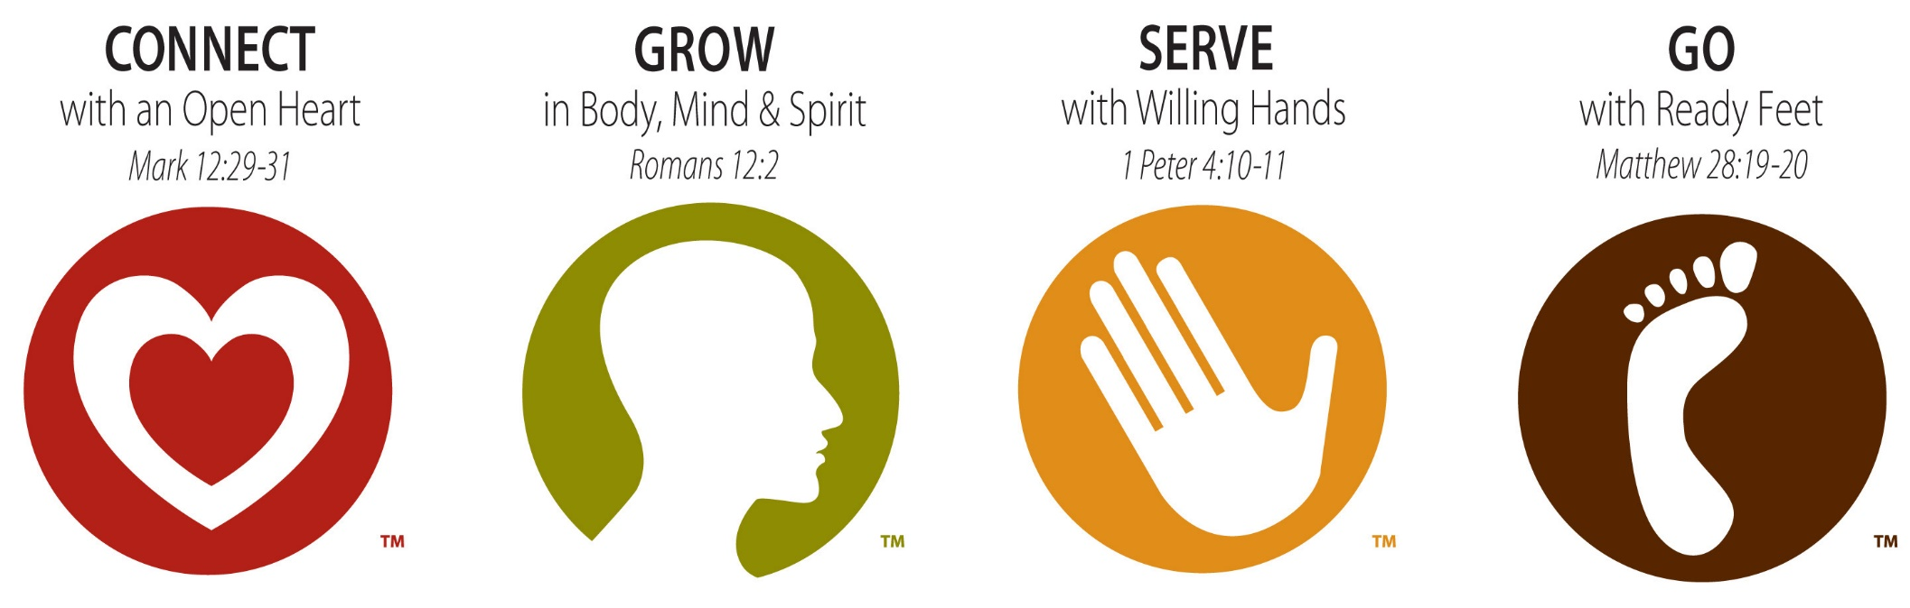
r
SAVE THE DATE!

We are offering another 'Feed My Starving Children' serving opportunity! We have reserved 47 spots for Saturday, May 20th from 2 pm - 4 pm
at their Libertyville, Ill packing site. If you are interested please check your calendar and make plans to join us and sign-up at the Connection Table in the south entryway. At this time, there will be no additional spots so don't delay in signing up!

Make Soup for the Lenten Soup & Sandwich Meals

We are looking for people to make and bring soup or casseroles for any of the meals on Wednesdays through April 12.

Please sign up at the Connection Table. Thanks.

Share your “Time & Talent” and further God’s work!

If interested in ministry areas contact the church office.
-Help watch and play with kids on the first Friday of each month from 6:00-8:30 p.m. to enable Christ Church to offer free child care so parents can have some time out. Contact church office.

-Audio/Visual Ministry, be trained to run the system during worship services. Contact Pastor.

-Sunday Door Opener or Greeter. People are needed to commit to opening the doors and greeting people one Sunday each month before worship. Contact: Liz Martin.

-Driver: Help pick people up for worship using the church van.

SCRIP
SCRIP = gift card – except with SCRIP, a portion of the value of the card comes back to Christ Church. Need a gift card for a graduate? Have a home improvement project? Planning a trip? By using a SCRIP gift card, your purchases not only meet your needs, but also help the ministries and mission of Christ Church. Pick up a SCRIP order form, to see how SCRIP can help with your plans. Use Christ Church’s “Order It” program and order your cards Sunday and pick them up as soon as Wednesday afternoon. Actual member experience – 4 days in hotel on vacation, paid with SCRIP - $48.00 to Christ Church Ministries. SCRIP cards can be purchased or ordered on Sundays here at church; or online at www.shopwithscrip.com. When enrolling online, use enrollment code 91LDB747375L9. All orders must be paid for before placing an order.
www.RightNowMedia.org
Our church is looking to help you live out your faith throughout the week. We are inviting you to have a free account to a video library called Right Now Media. It's essentially the "Netflix of Video Bible Studies" because you will have instant access to thousands of great videos for kids, youth, parents, singles, married couples and more. You can view these videos from your phone, tablet or computer. If you want to sign up please email the church office.

Join us in making shawls for those going through tough times. The shawls serve as a reminder of God’s love and the prayers of God’s people. We gather at
1:00 p.m. on the second Friday of each month in the Friendship Room at Christ Church. Due to Good Friday, we will not meet in April.
Reminder: If you know someone who could benefit from receiving a Loving Arms Prayer Shawl, please contact the church office at 632-1607.

Staff Emails

Kendra O’Connell (Office)
christchurchracine@tds.net

Pastor George Kafer
revkafer@outlook.com

Ryan O’Connell (Youth)
christchurchracineyouth@gmail.com

Liz Martin (Discipleship)
lizkmartin@msn.com

Merry Kris Demske (Adm.)
mkdemske@gmail.com

Your Giving Makes a Difference!

In March we sent our monthly apportionment to help support health and welfare ministries that directly serve over 50,000 people in Wisconsin through ministries like Children’s Service Center and Northcott Neighborhood House in Milwaukee.

Thank you to those who offer support for vital, life changing ministry.

To give online go to www.christchurchracine.com and click “give” or text “give” to 1-262-631-3012

God Is Good
God is working good in the lives of people through the ministries of Christ Church. If you have a story of how your life or someone else’s has been blessed by God or affected by a ministry at Christ Church please share it with Pastor George so God can be glorified.

April Birthdays

Meaning,

Purpose,

Hope

Learn how to find them at Christ Church!

Chris Ruud 4 6
Lauren Kell 4 8
Michelle Milbauer 4 8
Brian Wallace 4 9
Paul Sapp 4 10
Abe Bixler 4 11
Bob Herman 4 11
Andrew Kennow 4 13
Deanna Heidt 4 14
Lorraine Lee 4 15
Ruth Kiefer 4 17
Kathy Sponholtz 4 20
Mehran Balian 4 22
Jeremiah Fechner 4 22
Bob Stocks 4 24
Fred Valukas 4 29
Dennis Hermanson 4 30
Diane Rogstad 4 30

Lenten Meal, Worship & Study Continues

Wednesdays
Through April 12

5:15 pm Soup & Sandwich meal

6:00 pm “Not a Fan” - Sanctuary

A Lenten video & discussion based Bible study on each Sunday’s sermon.

Mission Project Collections
In the south entrance there are bins for collecting various items for mission projects and ministries. You can drop off items for the local food pantry, Campbell’s soup labels, and supplies for school.

Christ Church Men’s Bible Study
Wednesdays at 6:00 pm in the
Conference Room
Bring your Bible. Contact Brian Crowe for the current chapter being studied. Then read in advance of coming to class. Bring a friend with you. Let’s GROW!

The Evening Dinner Circle meets on
April 3 at 6:00 p.m. for dinner and a mission program.

The Ellen Circle meets on April 20 at 1:00 p.m. in the friendship room.

Sign up for Camp!

-Get $25 off (up to 4 times) for every friend you get to register.

-Christ Church gives $100 toward registration for member families.

-Conference Scholarship funds may be available to non-members by request.

Summer camp booklets are available on the hallway bulletin board.

Sunday

Adult Sunday School 9:00 – 10:00 a.m.
Meeting in Room 16 “Milk to Meat” A study of the six principle teachings of Jesus that every Christian needs.

Adult Sunday School 10:30 – 11:30 a.m. Meeting in Room 16
March 5-April 9 “Not a Fan” A video & discussion based Bible study on each Sunday’s sermon.
April 30-May 28 “Worshiper” A video & discussion based Bible study on each Sunday’s sermon.

Wednesday

Men’s Bible Study (Chapter by Chapter)
Led by Brian Crowe at 6:00 pm in the Conference Room

March 8-April 12 “Not a Fan” at 6:00 p.m. in the Sanctuary
A Lenten video & discussion based Bible study on each Sunday’s sermon.

Methodism 101 / April 26-May 31 / 6:00 pm Friendship Room
Learn core Christian beliefs and the structure of the United Methodist Church

April 26th, May 3rd, May 10th / 6:00 pm Room 16 – Led by Brian Wallace
Session 1 - Jesus in the Old Testament - The Prophecies / Session 2 - Jesus in the Old Testament - The Events
Session 3 - The Amazing Song of Moses (Exodus 15) / Bring your Bibles and a notebook.

Thursday

Woman’s Fitness Group
Dancercise along to a video in Fellowship Hall 5:30-6:30 p.m.

Adult Coloring Group
6:00-8:00 p.m. Meets on the Fourth Thursday in the Library

Friday

9:30 a.m.
March 10-April 14 “Not a Fan” A video & discussion based Bible study on each Sunday’s sermon.
May 5-June 2 “Worshiper” A video & discussion based Bible study on each Sunday’s sermon.

Prayer Shawl Ministry
Meets at church every 2nd Friday of the month at 1:00 p.m. in the Friendship Room
Will Not Meet in April Due to Good Friday

Saturday

Kindred Hearts Breakfast
For women who live alone, we meet to share a pot-luck breakfast.
Generally meets every other month. Next date TBA.

FEED MY STARVING CHILDREN

We are offering another 'Feed My Starving Children' serving opportunity! We have reserved 47 spots for Saturday, May 20th from 2 pm - 4 pm at their Libertyville, Ill packing site. If you are interested please check your calendar and make plans to join us and sign-up at the Connection Table in the south entryway. At this time there are only 47 spots available to our group so don't delay in signing up.

What Will Your Legacy Be?
Have you considered your legacy; how about continuing to let God use you to transform lives by adding a line to your Will that gives 10% of your estate to Christ Church. Estate funds have helped us with much needed building repairs or improvements so that our building continues to support vital ministry.
Friendship Luncheon
Wed., April 12th & 26th at 12:30 p.m. Make your reservations: Call Billie Stilley at 554-8801.
Open to all and friends of our community.

Apportionment Giving
Christ Church has a history of 100% apportionment giving, allowing us to help transform lives by God’s love. Apportionments provide for ministries that directly help over 50,000 people in Wisconsin and many more beyond. In 2017 our apportionment is $44,220; if we each give faithfully to the general fund and if able a special gift for apportionments, $200 a year per member, we can continue to support connectional ministries and free up more of our general funds to increase outreach and ministry in our local area.

Stewardship Makes a Difference!
Thank you for all the ways you support ministry. This newsletter has examples of how our church is making a difference in people’s lives through your giving! It is good to see people trusting in God and answering His call to give. People are offering themselves to serve and their financial giving (several tithing 10% of income, or working toward tithing)! Check the connection table for Electronic Fund Transfer forms and ways to give of your time and talent as well. As you respond to God’s call in the giving of your time, talent, and resources remember if you have a need contact Pastor George.

Consider This
If you desire to give to specific ministries beyond your general offering here are some areas: Apportionments,
Building Fund
(helps with: painting, siding, repairs, parking lot…),
Compassionate fund,
Roof Fund, Youth Ministry,
Audio/Visual Fund,
Camp Scholarships
($100 per camper).

New Message System

Text “connect” to 262-631-3012

Follow the instructions once you receive a reply back. This communication system will allow us to send special messages (meeting cancelations…) or reminders to you. Sign up today.

Music Ministry
at Christ Church

Praise Team
Provides/leads praise and worship songs at our Sunday Contemporary worship. Practices currently on Tuesdays at 6 p.m. year round.

Chancel Choir
Provides special music and leads hymns at our Sunday Traditional worship. Sept.-May. Practices on Wednesdays at 7:00 p.m. Sept.-May.

Special Music
Please contact Alan Biehn

Christ Church’s Vision

A church that seeks, welcomes, and forms in Christian faith all people with a special focus at this time on reaching out more to families and children, increasing our connection with and ministry in the community, and forming more small groups to grow people in relationship with Jesus and one another.

Membership Expectations
By taking the vows of membership members of Christ Church agree to help carry out our mission and to be: regular in worship; active in spiritual growth (personal devotions/growth groups); active in an area of service in the church and/or
community; to give in proportion to your income, and to be a witness to the faith. These vows help us grow in faith and live it out in the world as followers of Jesus.
Need a Visit?

Gifted lay people along with the Pastor extend the Church’s presence to the homebound and others through visits. If you have moved, are ill, having surgery, or need a visit for any reason please call the church office to keep the Pastor and lay visiting team informed. If we do not know we cannot go!

We have bundles of worship invite cards in the entryways to take and give out:
- Put a stack at your office, store or place of work.
- Ask if you can set a stack out in a business that you frequent.
- Give them to neighbors, friends and co-workers.
- Leave them on tables at restaurants to invite your server (leave a tip, too).
- Give them out in drive thru lanes.
- Ask God to give you an opportunity to give them out.
- Keep a few in your wallet, purse or car.

Christian Education, Children’s, Youth & Family Ministry

Sunday School September 11 – May
On Sunday morning grade level classes are offered for kids age 3 – 5th grade.
Students are dismissed during the 10:30 worship to attend classes in the north and south hallways.
Preschool – Room 14 led by Angela Furuglyas
K - 2nd Grade Room 2 led by Tyler Bosch
3rd - 5th Grade Room 7 led by Samantha Wallenta
Middle & High School (6th-12th Grade) are to attend worship and then on the 2nd & 4th Sundays stay after for a meal and class in Room 13 led by Ryan O’Connell and adult lay leaders.

Wednesday Kid’s Club
A gathering for K– 5th graders in Room 14 from 5:45 p.m. - 7:00 p.m. where kids grow to follow Jesus as they learn Biblical teachings through hands on activities like: songs, videos, drama, crafts, Bible stories, games, and mission projects. Classes are right after a free meal (5:15 p.m.)

Confirmation Class
A two year class meets on Wednesdays 4:30-5:15 p.m. Classes on April 5, 12, 26,
Using classes, youth group, mission trips, and participation in church life confirmation helps youth learn about and confirm the Christian faith. Led by Pastor George

-------------------------------------------------------------------------------------------------------------------------------------------------------------

On Sunday April 16th Kid’s Club kids share in the 10:30 a.m. worship gathering.

-------------------------------------------------------------------------------------------------------------------------------------------------------------

Youth Group Schedule
Wednesday night gatherings from 6:00 pm-7:30 pm: Spend time together, learn about God’s word, and serve the community around us. Come hang out on Thursdays from 3:00-5:00 p.m.

Family Ministry
-Child Care for 4yrs. and under offered in the nursery on Wednesdays during the classes, 6:00-7:00 p.m.
- “Parent’s Night Out” first Friday of the month, Free Child Care from 6:00-8:30 pm
- Annual Easter Egg Hunt (Bunny Trail) April 1 from 2:00-4:00 p.m.
-Easter V.B.S. April 8, 1:00-3:00 p.m. Children play games, hear stories, have snacks and learn about Jesus.

Options for Kids During Worship
Worship Clipboards are located in the south entryway for children Preschool - 3rd grade.

A nursery room for 5 year olds and under is staffed with professional child care for parents who want it.

Other Youth Opportunities
Boy Scouts: Meets at Christ Church on Mondays from 6:30-8:00 p.m.

Venturing (coed scouting group for 14-18 year olds)
For more information email Billie at 225committeechair@gmail.com

Change for Change

During the month of April, our Change for Change will be donated to Bethany Apartments. These are apartments set aside for women and their children who have had to leave their homes due to domestic abuse. After they leave short term facilities such as the Women's Resource Center, they can live in Bethany Apartments for up to two years while they pursue an education and get a job. The cost is only what they can pay, and they have many common facilities in order to help each other. They live in a secure facility so they no longer have to worry about the safety of themselves or their children. Often they have practically nothing when they arrive at Bethany. United Methodist Women took up a collection of paper products for them at our last meeting when they heard they were running very low. We will be having an altar call during the month of April for a specific need at Bethany on a Sunday to be announced.

Easter Offering
The Easter offering will be sent to the United Methodist Chaplaincy Program in Madison. Our Chaplain there visits all the Madison Hospitals where people from around the state travel if they have needs that cannot be met in their own community health facilities. If you are a United Methodist you will receive regular visits from our "Chaplain" while you are there. If your family cannot be with you and your own clergy cannot come, this is a real blessing.

April 7

On the first Friday of the month, parents are invited to drop off their kids (3 months-5th grade) at Christ Church for free child care from 6:00-8:30 p.m. where games, activities, and snacks will be provided.
This is a way to support families in our congregation and community by allowing parents to have time for themselves and their relationships.
Please sign - up children at the connection table or call the church office at 632-1607. Those wishing to help may sign up at the connection table as well. Chris Bahr, PNO Director

Passport To The Bunny Trail
Saturday April 1st 2:00 – 4:00 P.M.

The 4th annual Easter Egg Hunt has a new twist this year. Children age 10 and under will stop at 10 locations along the trail. At each stop children will play a game or be asked to perform a task; then they will have their passport stamped. Finally at the end of the trail, with a fully stamped passport, they will meet the Easter Bunny. As the well-traveled children say goodbye to the Easter Bunny they will all be given a goodie bag, thanks to your donations of candy. Our trail is inside. While along the bunny trail, hungry travelers can stop at the oasis to purchase a hot dog plate for $1.50.

Spring Family Funfest April 8th 1 – 3 pm

Free Community Event for families with children in preschool – 5th grade. Families will move station to station, learning, trying and creating surprising new things. It will be a presentation of the Easter story in a new, amazing way! Snacks will be provided and each child will leave with a surprising sack of goodies to help remind them of the new things they have learned! Sign up now at christchurchracine.com.

Sunday | Monday | Tuesday | Wednesday | Thursdayy | Friday | Saturday
 |  | April |  |  |  | 1  Easter Egg Hunt – “Passport to the Bunny Trail” – 2 pm – 4 pm
2  9 am Traditional Worship  10:30 am Contemporary  Worship & Sunday School | 3  9 am Racine Garden Group -Rm 16  2 pm Grief Support Group  6 pm Evening Dinner Circle- Rm 16  6:30 pm -Scouts | 4  All Day -Spring Election - FH  6 pm  Praise Band | 5  4:30 pm Confirmation  5:15 pm Meal  5:45 pm Kid’s Club  6 pm Fusion  6 pm MIM  6 pm “Not a Fan” Lenten Study - Sanctuary  7 pm Choir | 6  12:30 pm UMW Bd Mtg - CR  3 pm Connection  5:30 pm Ladies’ Fitness | 7  9:30 am “Not a Fan” Small Group - FR  6 pm – Parent’s Night Out  6:30 pm Venturing- FR | 8  9 am Witness FR  Saturday Sack Lunch  Spring Family Funfest  1 pm – 3 pm
9 Palm Sunday  9 am Traditional Worship  10:30 am Contemporary  Worship & SS  12 pm MS/HS Break Out Groups | 10  10 am Circuit Laity Mtg - CR  6:30 pm Scouts  6:30 pm Leadership Bd. | 11  6 pm Praise Band  6:30 pm – D.A.R. – Rm 16 | 12 12:30 pm Friendship Lunch  4:30 pm Confirmation  5:15 pm Meal  5:45 pm Kid’s Club  6 pm Fusion  6 pm MIM  6 pm “Not a Fan” Lenten Study – Sanc  6:00 pm Venturing-Rm 16  7 pm Choir | 13  7:00 pm  Maundy Thursday Worship | 14  9:30 am ”Not a Fan” Small Group - FR  7:00 pm  Good Friday Worship | 15
16 EASTER  9 am Traditional Worship  10:30 am Contemporary  Worship & SS  Kid’s Club Singing | 17  6:30 pm -Scouts | 18  6 pm Praise Band  6 pm Trustees | 19  5:15 pm Meal  5:45 pm Kid’s Club  6 pm Fusion  6 pm MIM  7 pm Choir | 20  1 pm – Ellen UMW Circle  3 pm Connection  5:30 pm Ladies’ Fitness | 21  9:30 am Sm Group FR | 22
23  9 am Traditional Worship  10:30 am Contemporary  Worship & SS  12 pm MS/HS Break Out Groups | 24  6:30 pm -Scouts | 25  9 am Hospitality & Membership -Library  6 pm Praise Band | 26 12:30 pm Friendship Lunch  4:30 pm Confirmation  5:15 pm Meal  5:45 pm Kid’s Club  6 pm Fusion  6 pm MIM  6 pm “Jesus in the Old Testament” - 16  6 pm – Methodism 101 - FR  7 pm Choir | 27  3 pm Connection  5:30 pm Ladies’ Fitness  6 pm Coloring Group - Library | 28  9:30 am Sm Group FR | 29  Noon – 2 pm  Boy Scout Car Wash
30

9 am Traditional Worship
10:30 am Contemporary
Worship & Sunday School

Christ Church United Methodist
5109 Washington Avenue
Non-Profit
Organization
U.S. Postage
PAID
Racine, WI
Permit No 24
Racine, WI 53406

CHANGE SERVICE REQUESTED

Our Worship Schedule April 2017

Sunday, April 2 9:00 a.m. Traditional & 10:30 a.m. Contemporary
“Fan or Follower: Rules or Relationship”
John 8
Communion Offered

Sunday, April 9 9:00 a.m. Traditional & 10:30 a.m. Contemporary
“Fan or Follower: Is Jesus Enough?”
John 6

Thursday, April 13
Maundy Thursday 7:00 p.m. Joint Worship

Friday, April 14
Good Friday 7:00 p.m. Joint Worship

Sunday, April 16 9:00 a.m. Traditional & 10:30 a.m. Contemporary
Easter Sunday
John 20:1-18

Sunday, April 23 9:00 a.m. Traditional & 10:30 a.m. Contemporary
“Playing Church?”
Acts 5:1-11

Sunday, April 30 9:00 a.m. Traditional & 10:30 a.m. Contemporary
“Worship with all your Heart”
Mark 12:28–31

