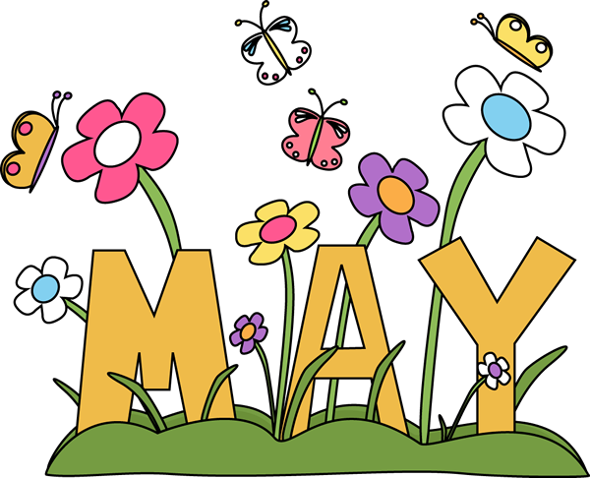
Dear Families,
It was amazing watching the preschoolers sing at our Spring Concert. Thank you all for coming! May is going to be a very busy month, as we wrap up the last month of the school year!
Important Dates:
May 7-11 Teacher Appreciation week
11th- Mother’s Day Tea Party @3:30
13th – Mother’s Day
28th – CLOSED Memorial Day
30st- Jr K and Pre K Graduation @10 am

Monday is Pizza Day!

